Circular–Organic Closed Shapes
# Source: AI Source: Provided by: [Data Path: Persons Table -> ID Column: 1, Name_En Column: Motasem Essam] -> From: [ChatGPT] on [7/25/2026]
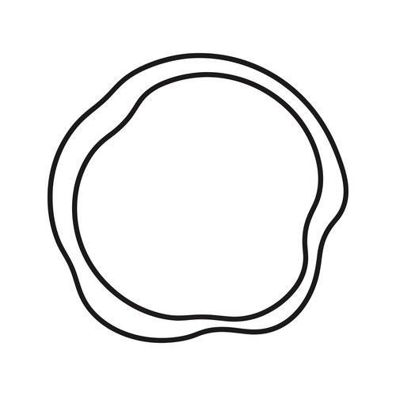
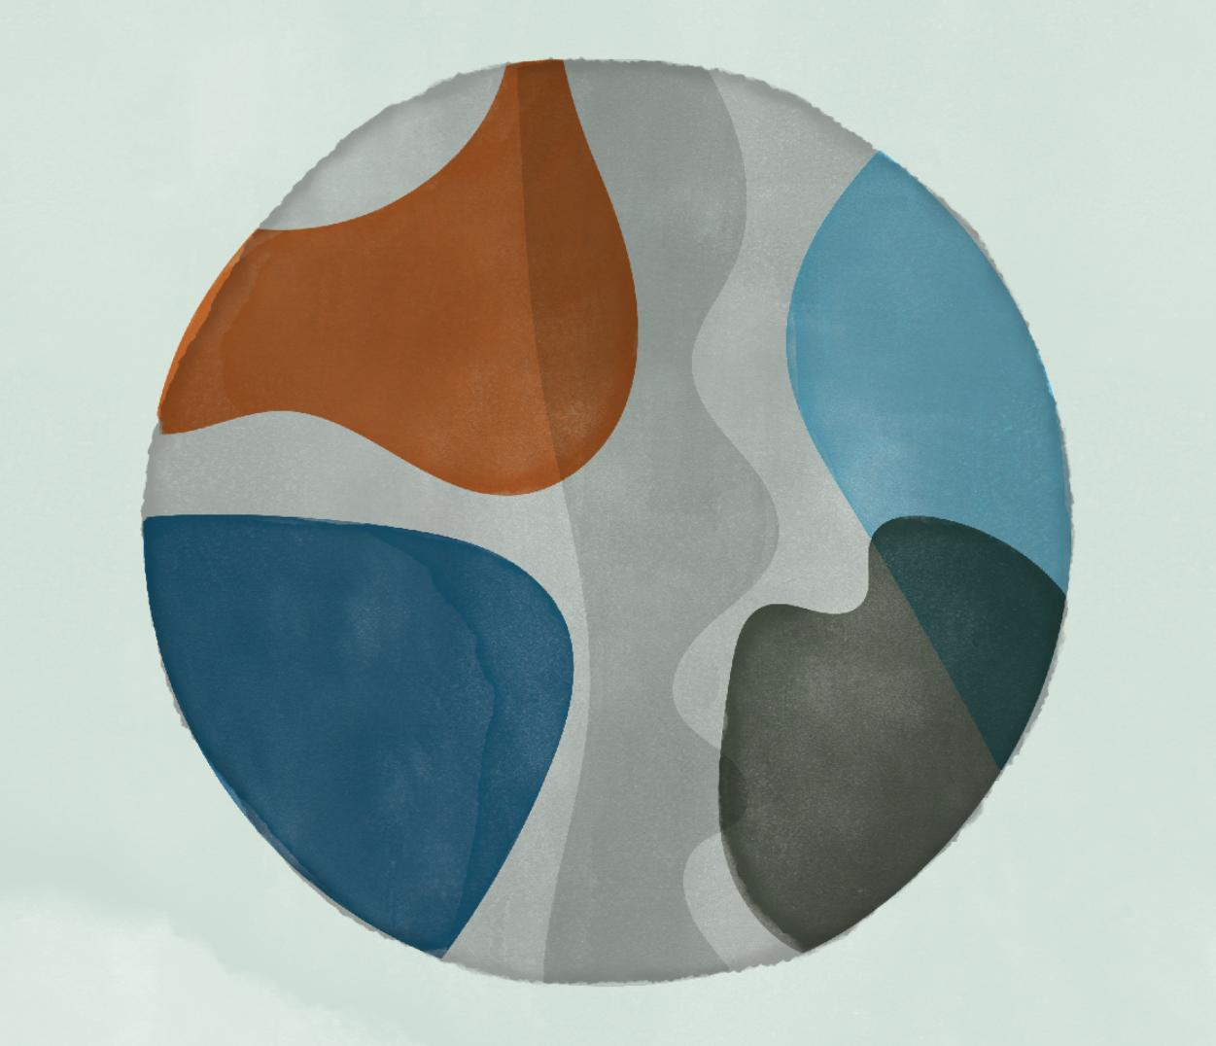
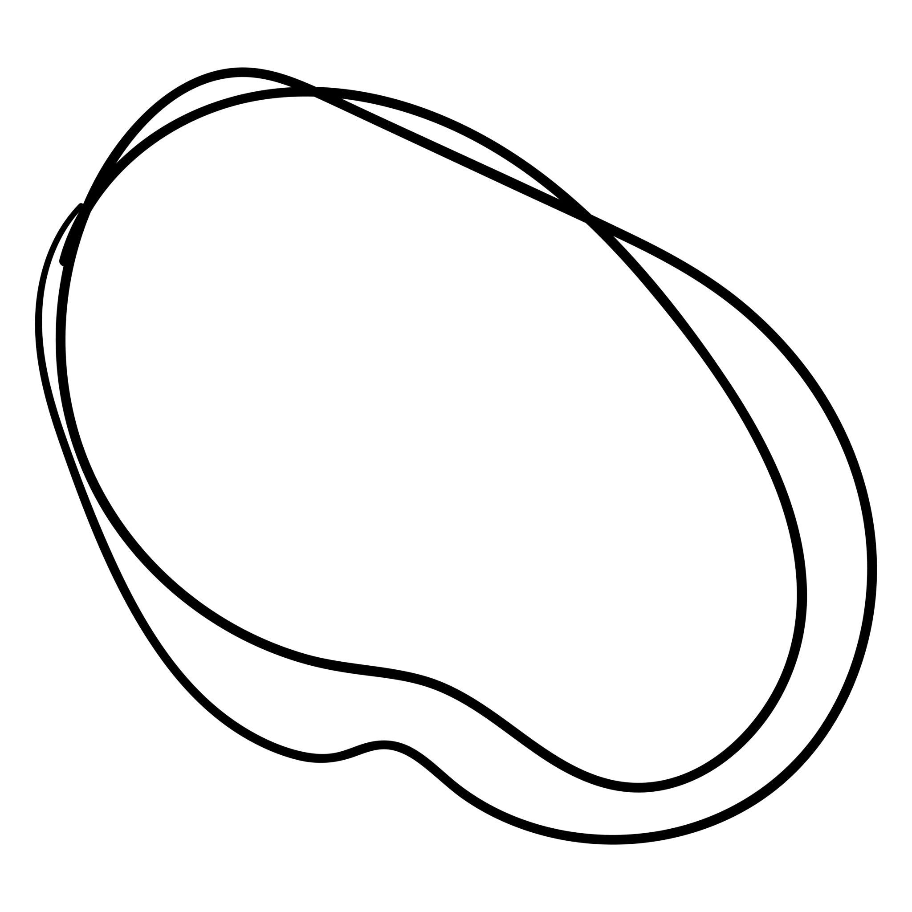
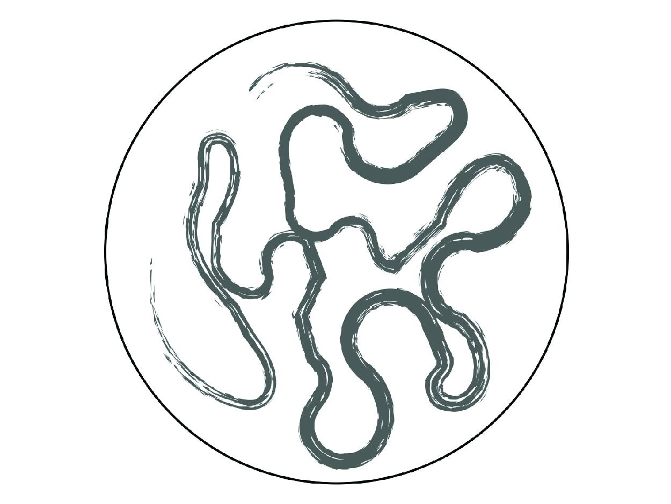
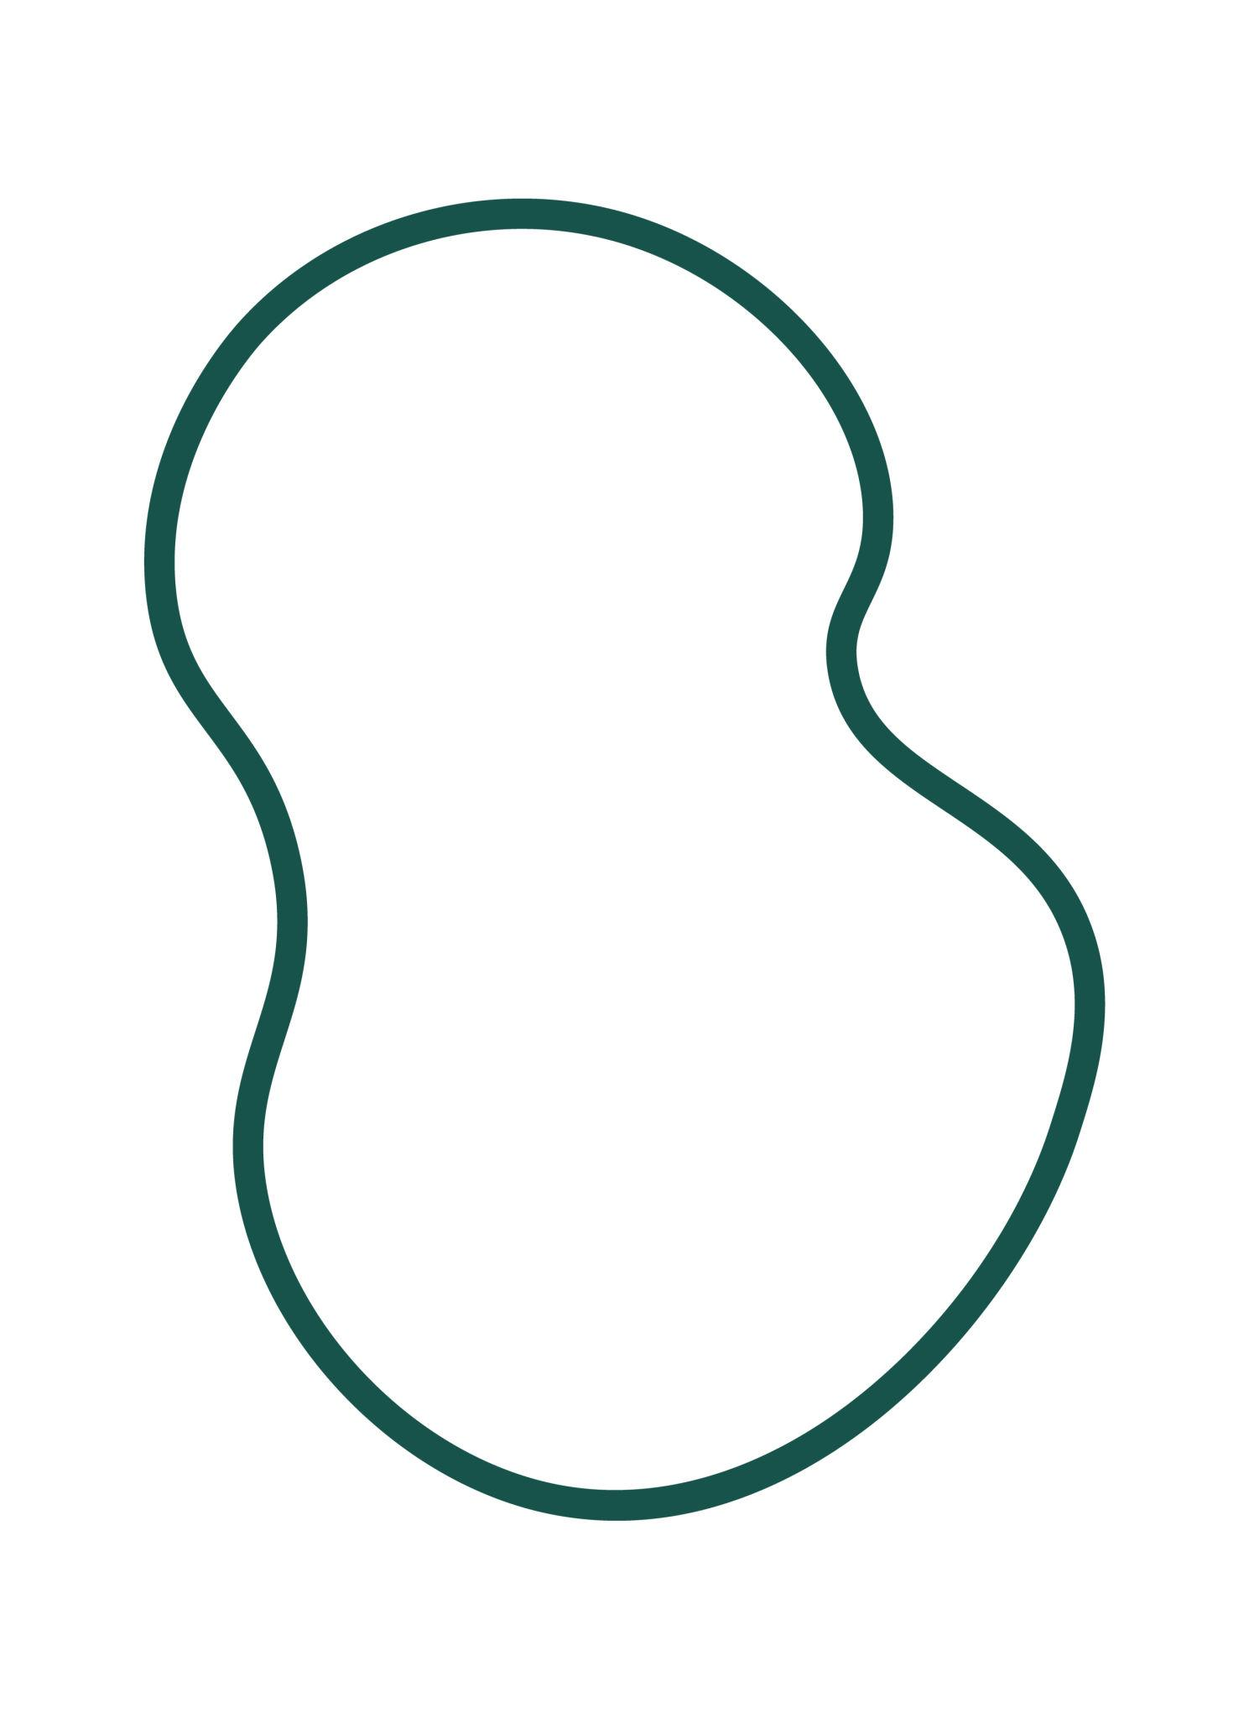

Definition
# Source: AI Source: Provided by: [Data Path: Persons Table -> ID Column: 1, Name_En Column: Motasem Essam] -> From: [ChatGPT] on [7/25/2026]
A Circular–Organic Closed Shape is a closed mixed shape whose boundary combines a circular component with one or more smooth, irregular, organic-looking curved components.
$$\boxed{\text{Circular–Organic Closed Shape}=\text{Circular Component}+\text{Organic Curves}+\text{Closed Boundary}}$$
The defining feature is that the shape contains both circular geometry and organic/freeform curvature.

Types of Circular–Organic Closed Shapes

1. Circle–Organic Curve Closed Shapes
# Source: AI Source: Provided by: [Data Path: Persons Table -> ID Column: 1, Name_En Column: Motasem Essam] -> From: [ChatGPT] on [7/25/2026]
A circular portion is connected to an irregular, organic-looking curve to form one closed boundary.

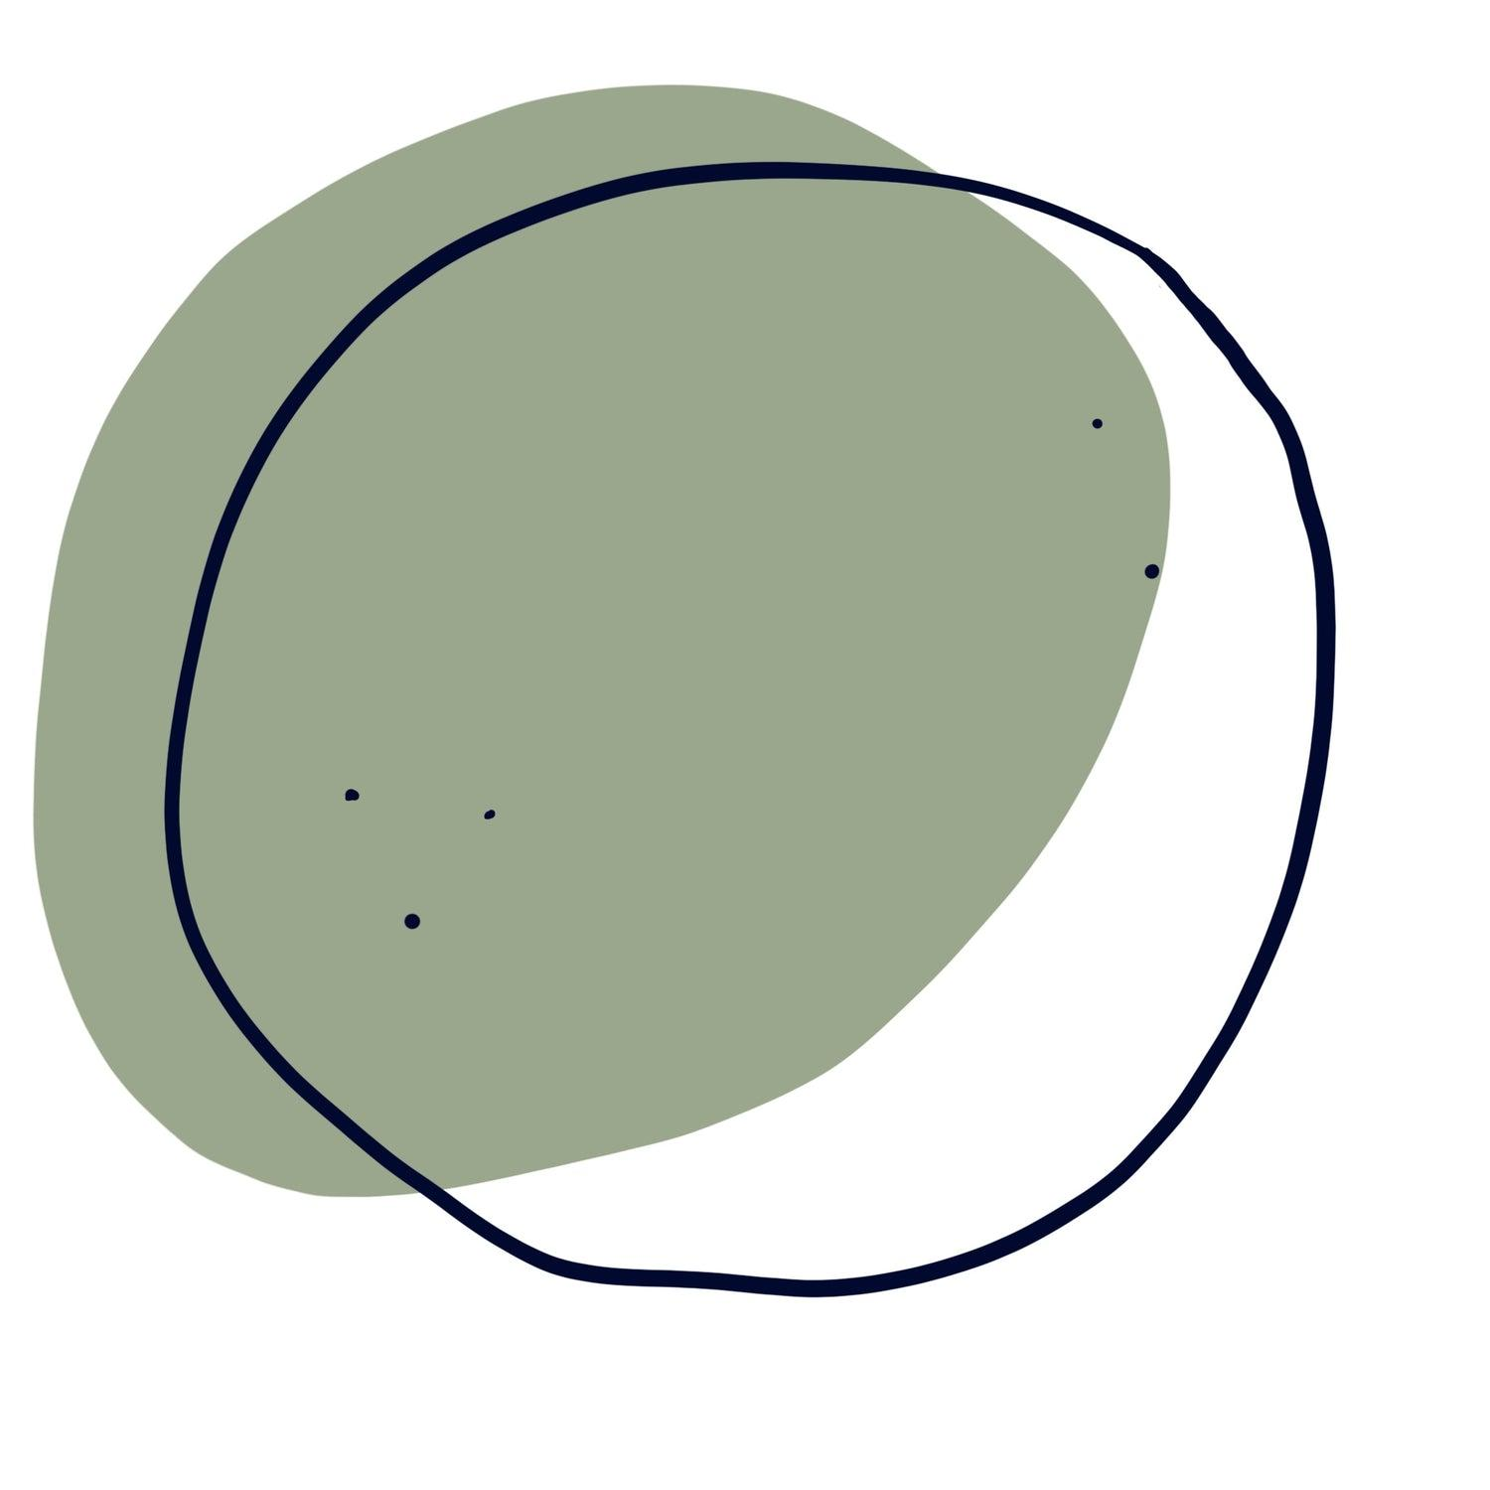
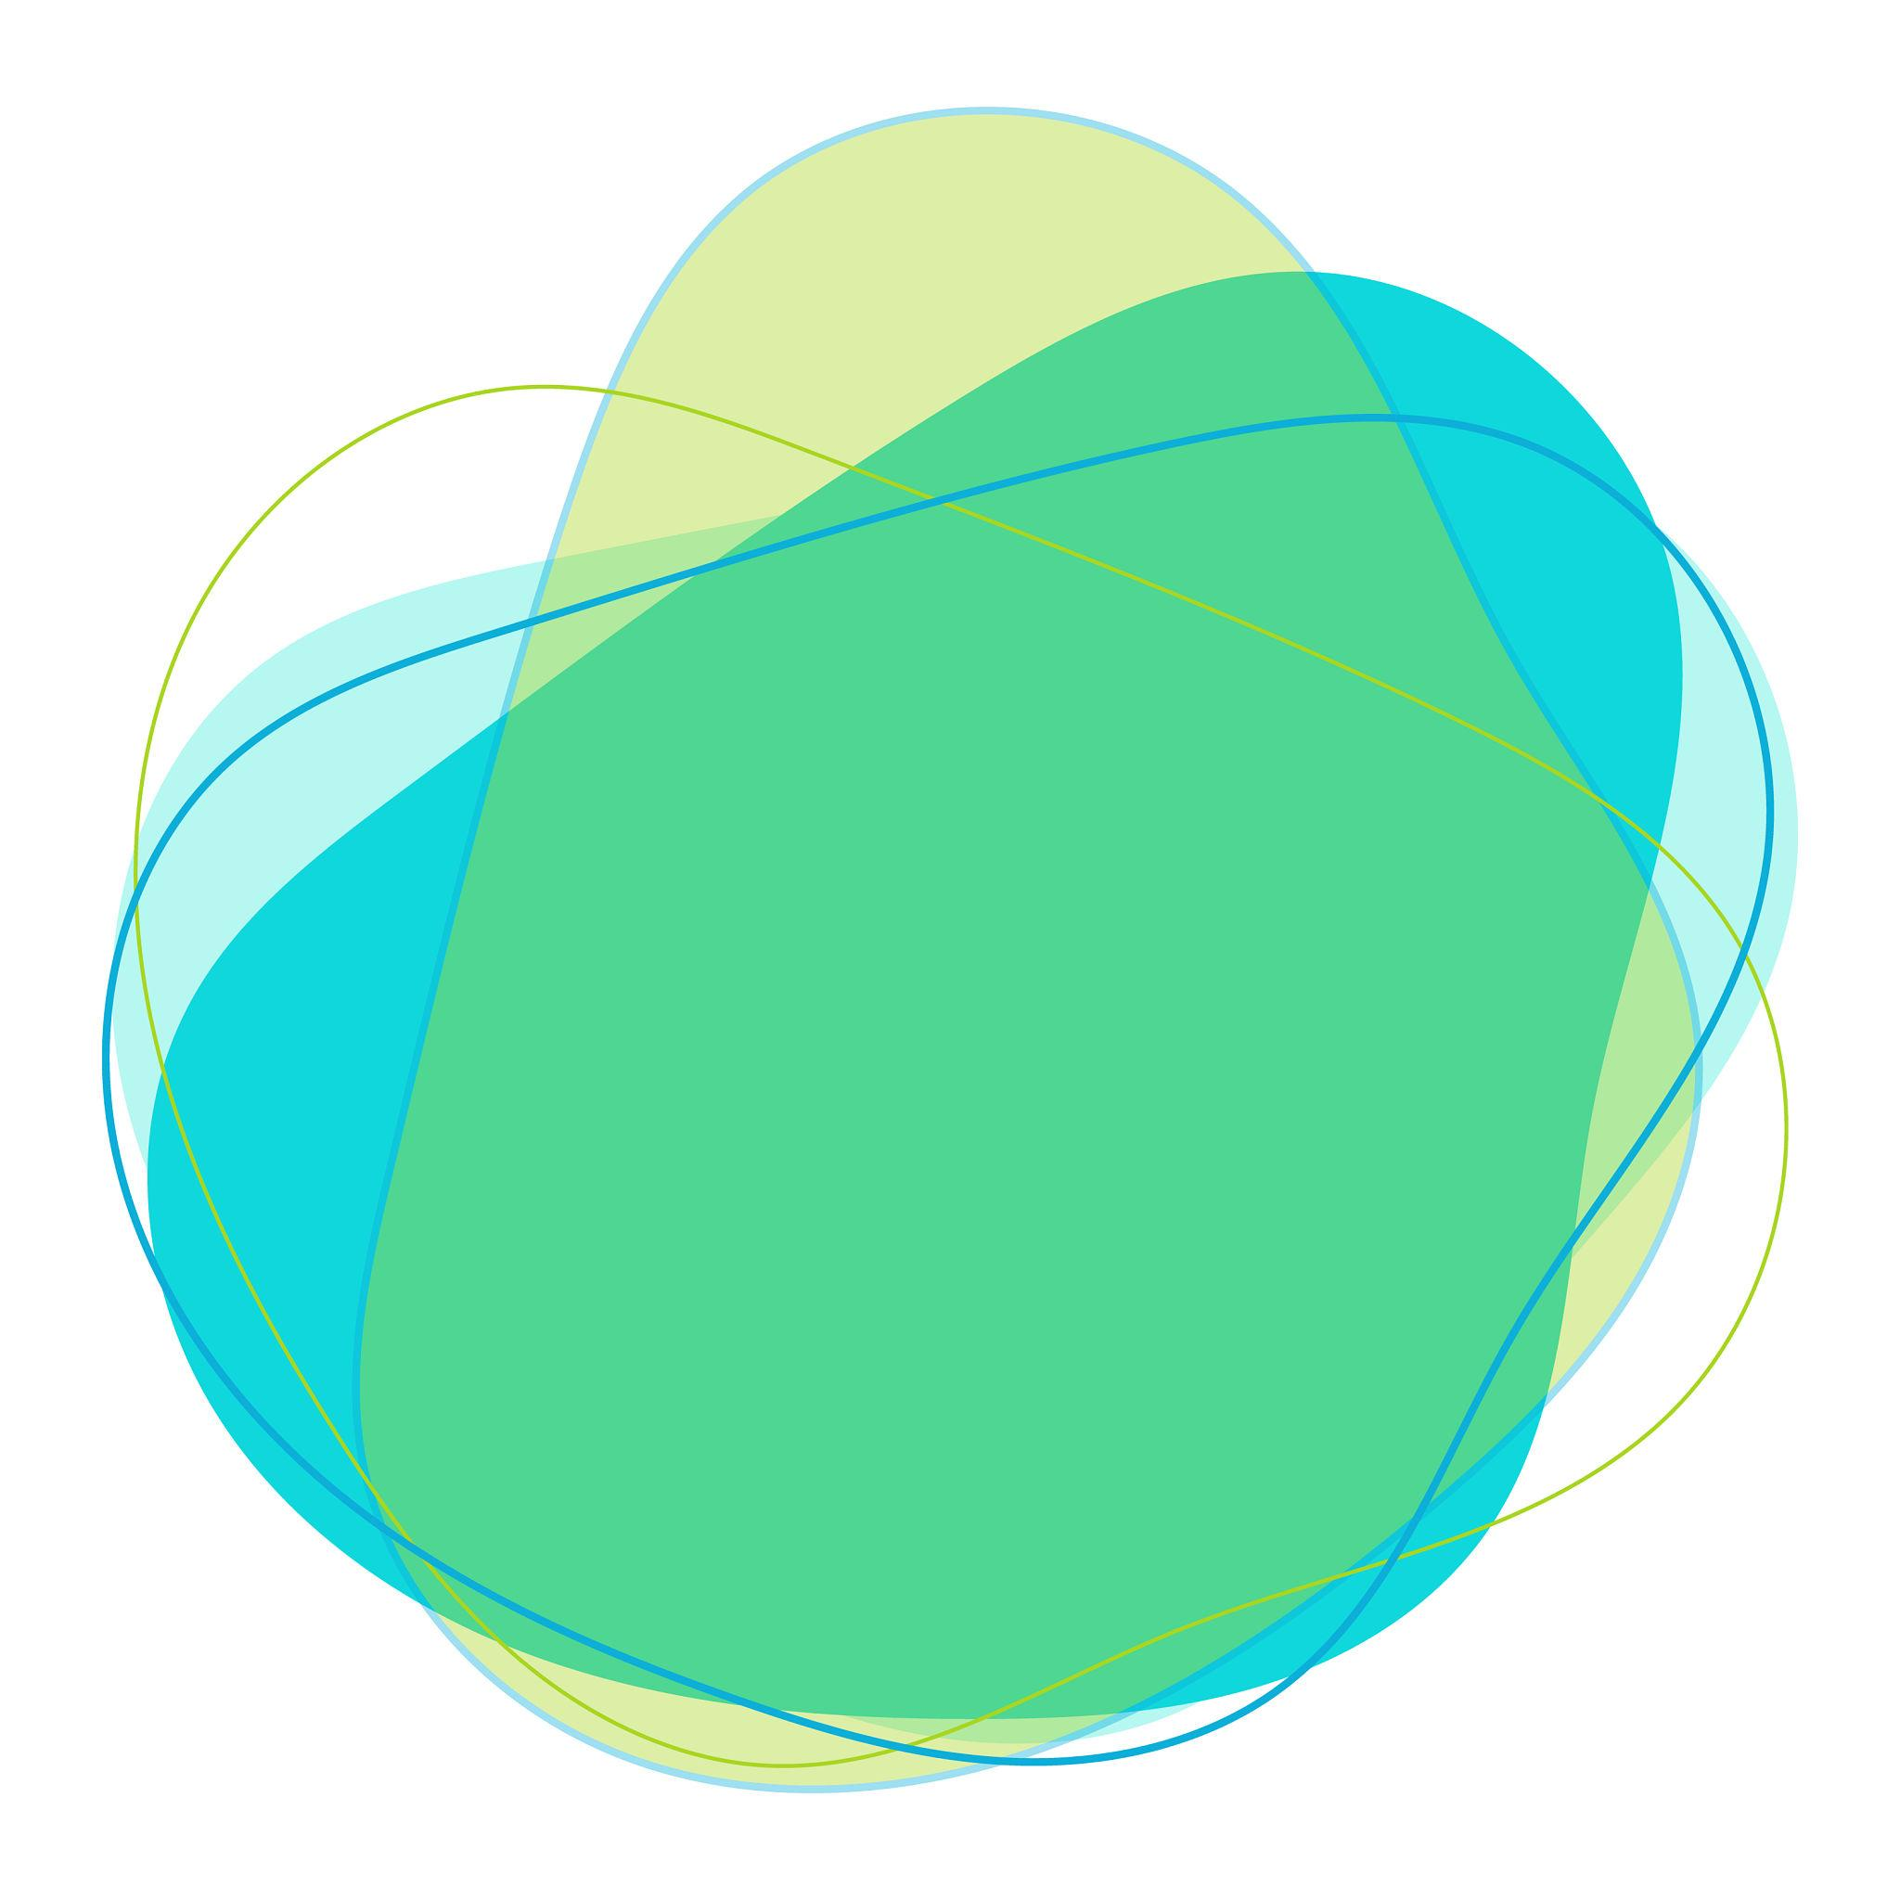
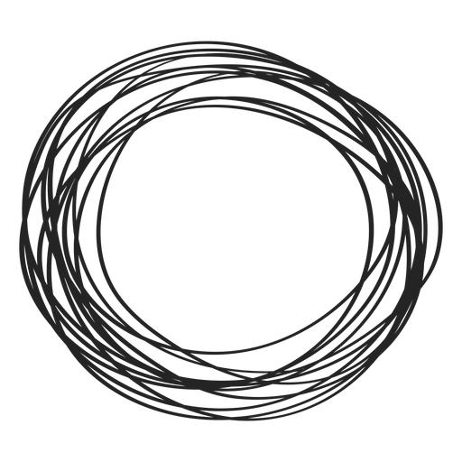
$$\boxed{\text{Circular Arc}+\text{Organic Curve}}$$

2. Circle–Leaf-Like Closed Shapes
# Source: AI Source: Provided by: [Data Path: Persons Table -> ID Column: 1, Name_En Column: Motasem Essam] -> From: [ChatGPT] on [7/25/2026]
A circular component is combined with a curved portion resembling a leaf.
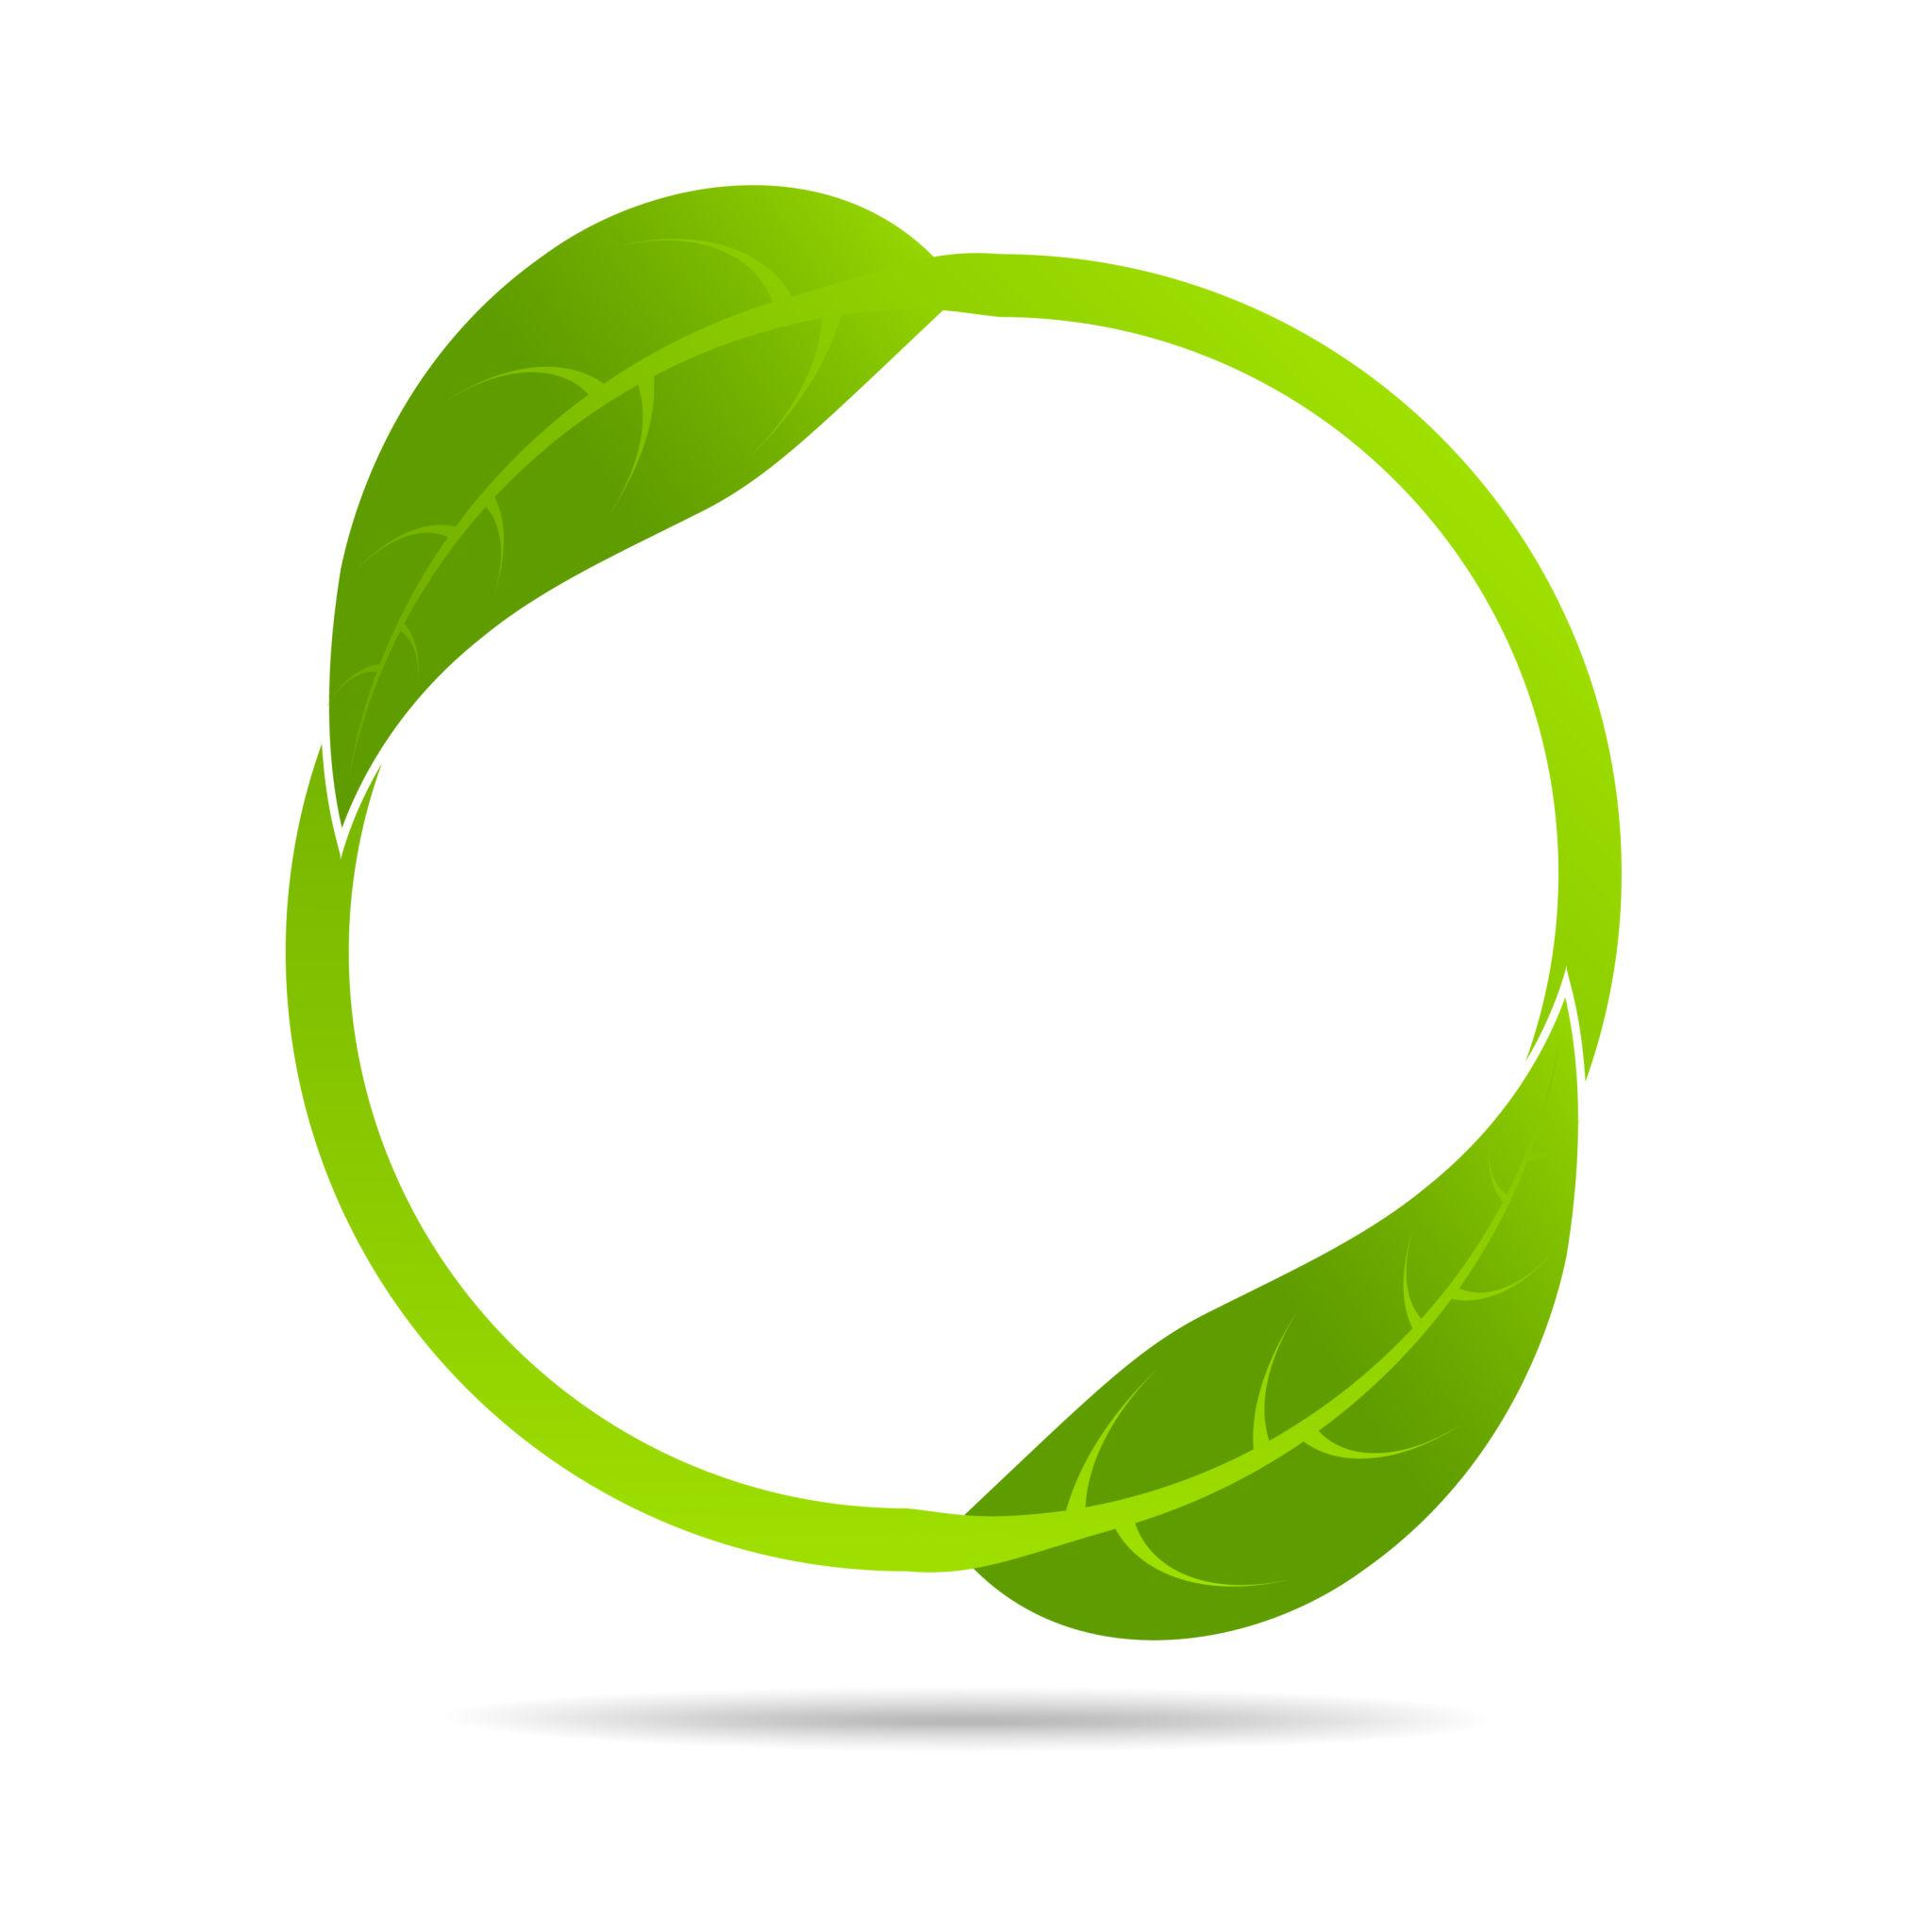

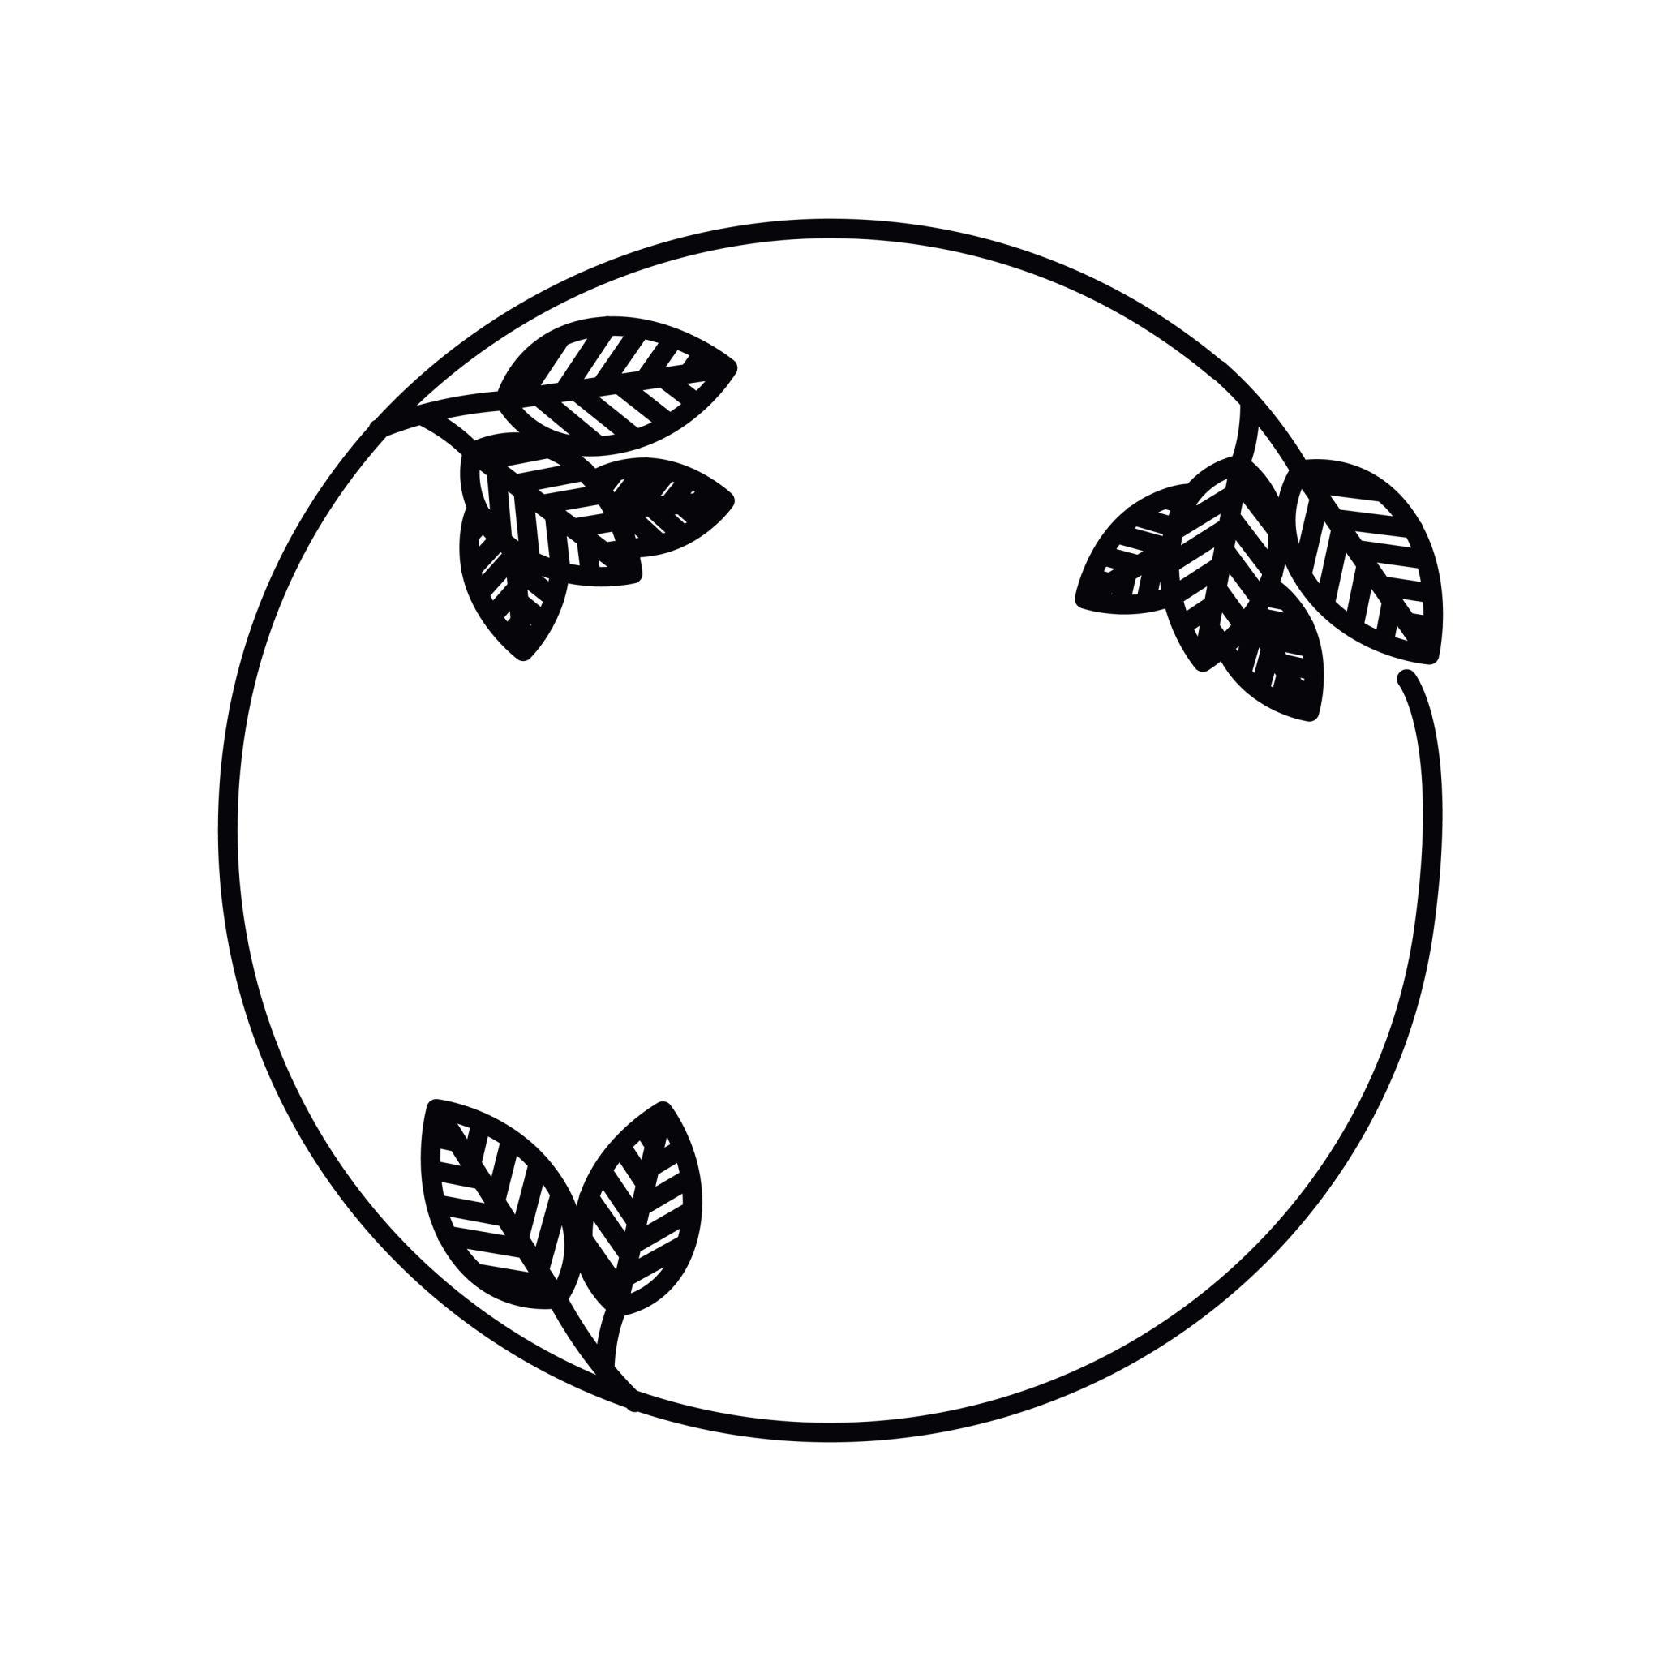
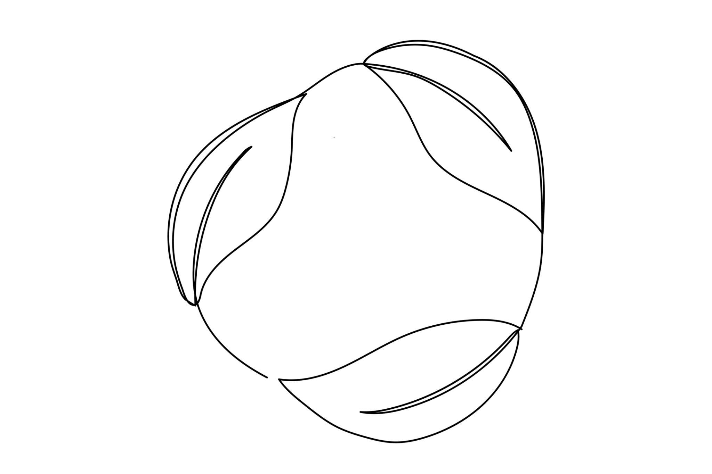
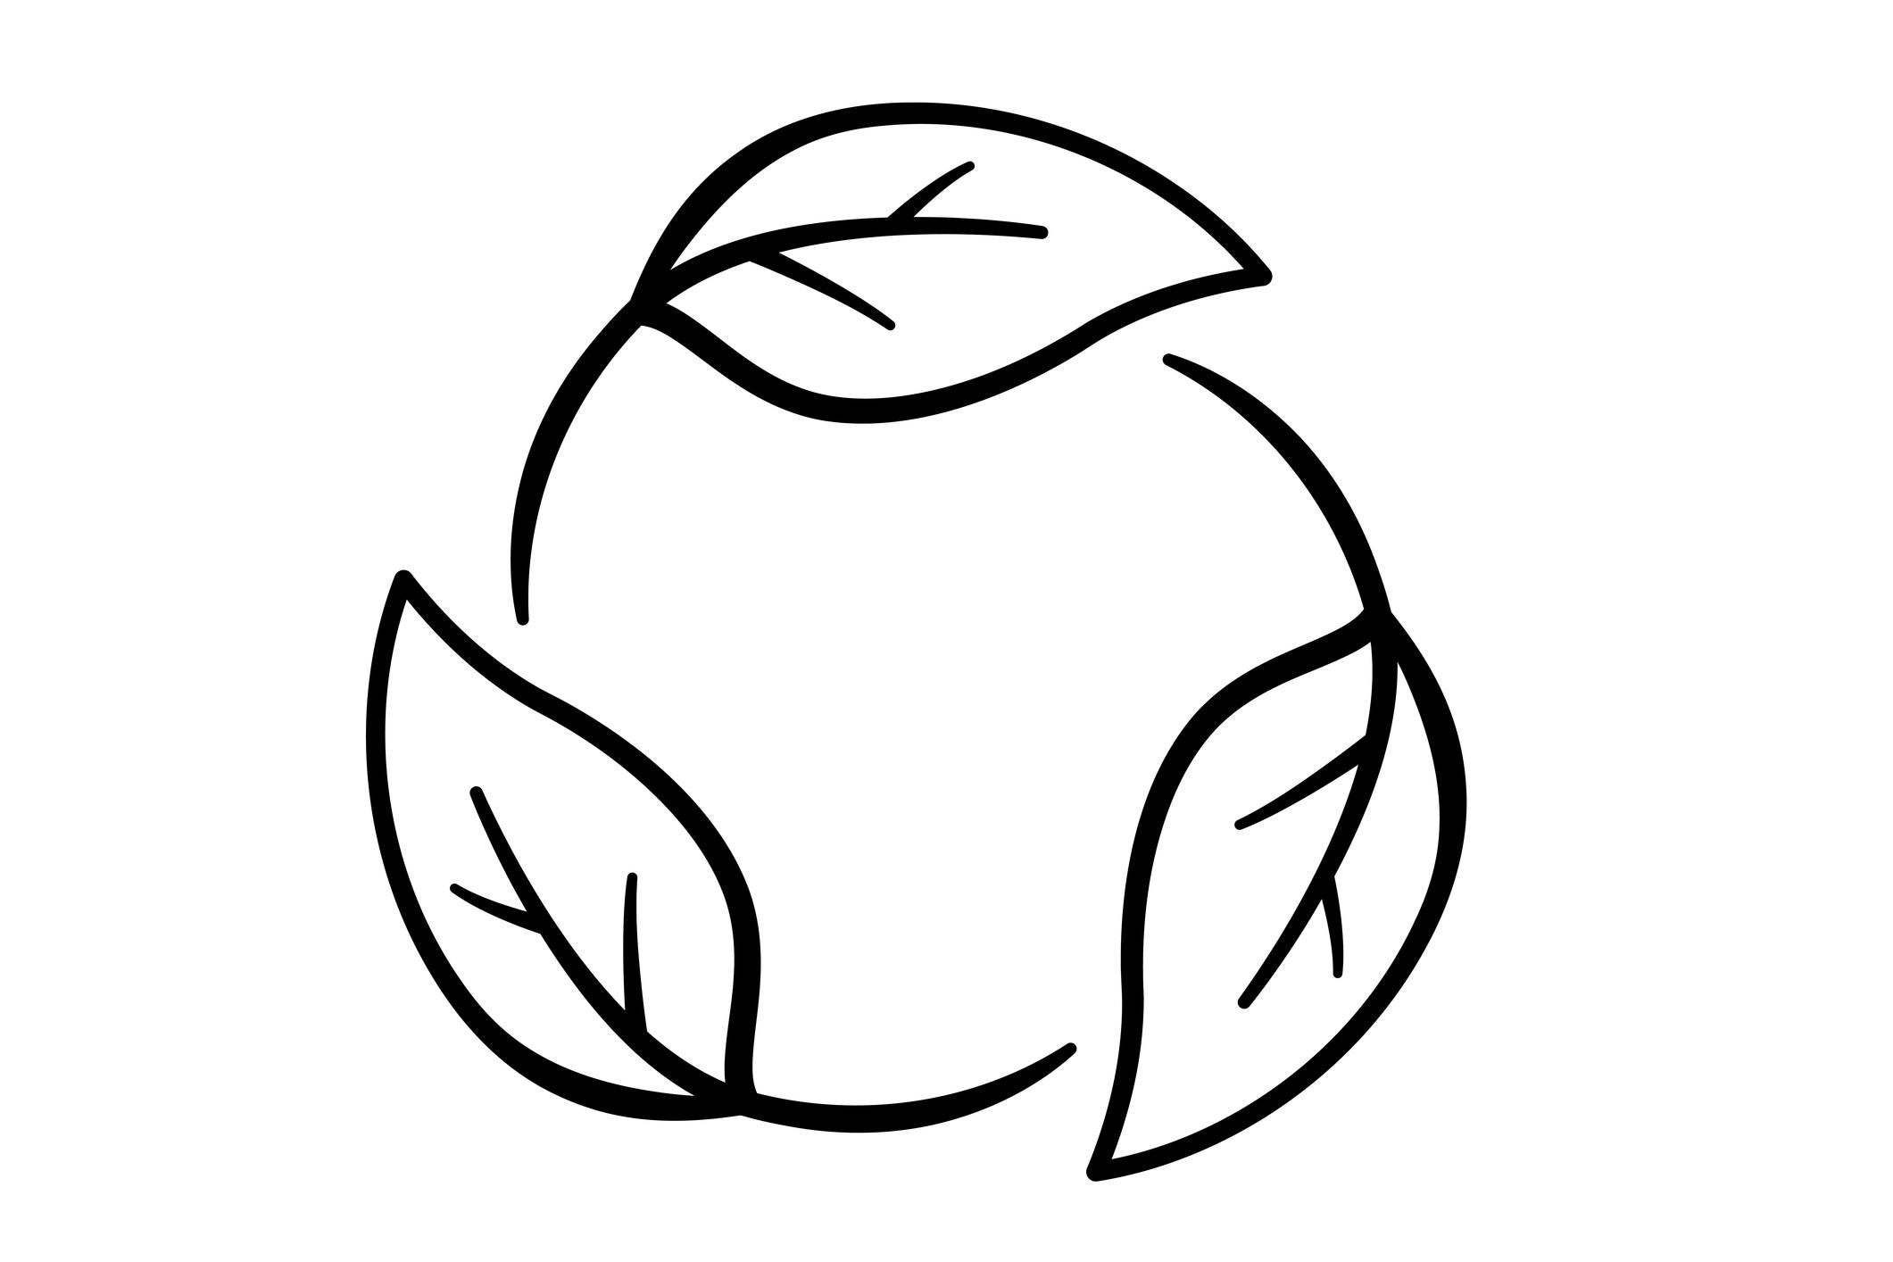
The organic portion does not need to follow a standard geometric equation.

3. Circle–Lobed Organic Closed Shapes
# Source: AI Source: Provided by: [Data Path: Persons Table -> ID Column: 1, Name_En Column: Motasem Essam] -> From: [ChatGPT] on [7/25/2026]
A circular portion is combined with rounded organic lobes.
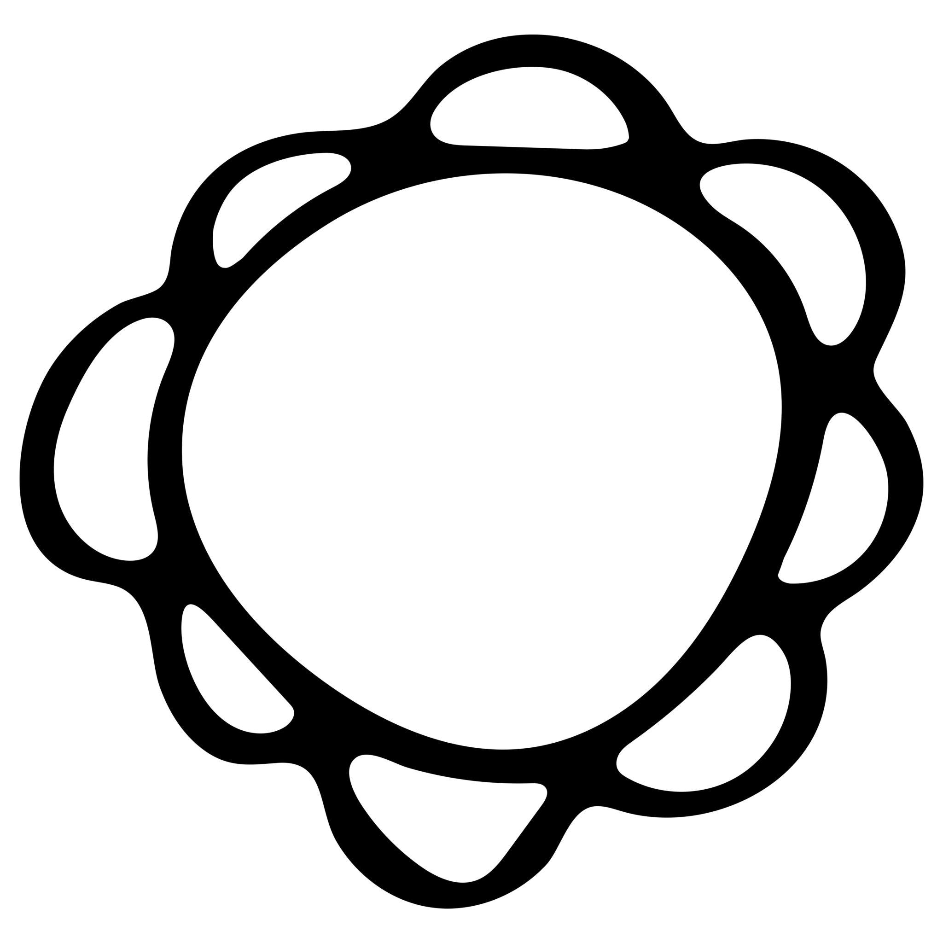
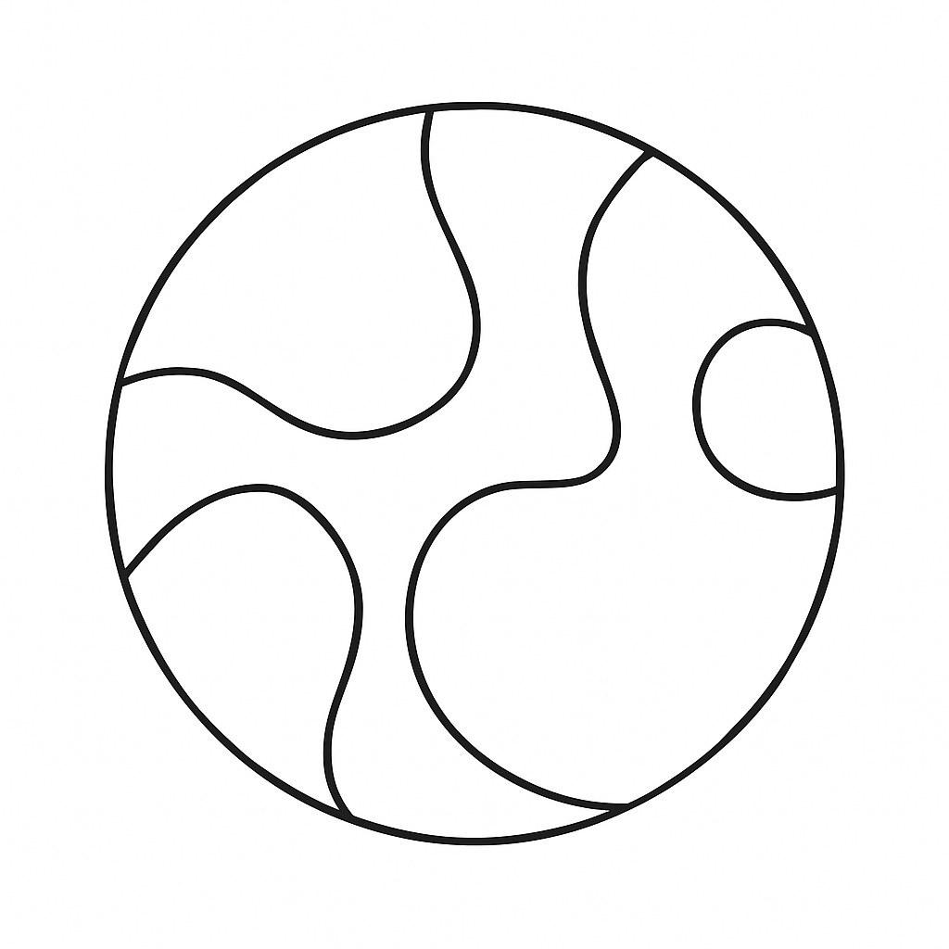
The lobes may be:
- Equal.
- Unequal.
- Symmetric.
- Asymmetric.

4. Circle–Wavy Organic Closed Shapes
# Source: AI Source: Provided by: [Data Path: Persons Table -> ID Column: 1, Name_En Column: Motasem Essam] -> From: [ChatGPT] on [7/25/2026]
A circular portion is combined with an irregular wavy boundary.
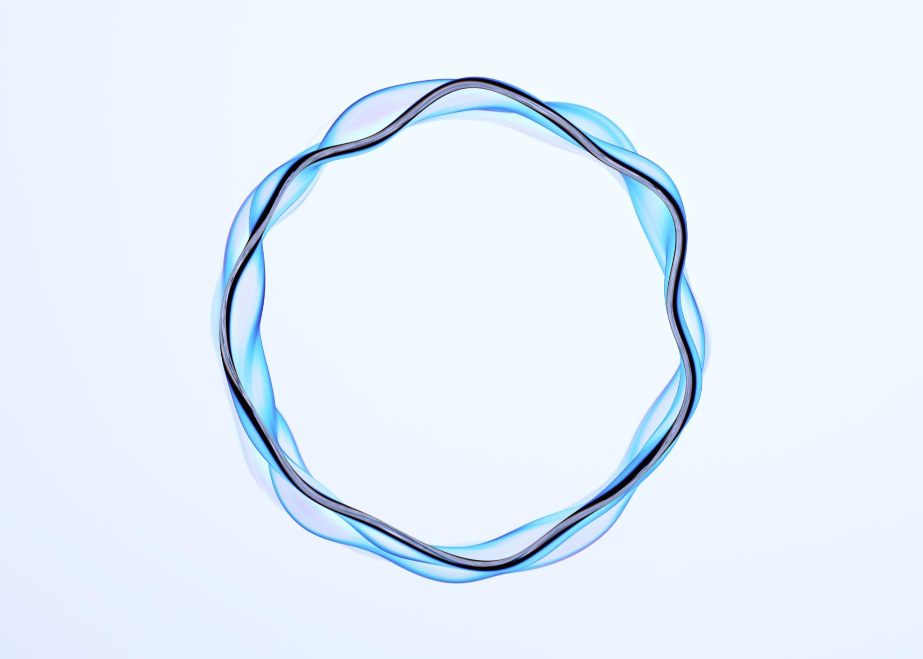
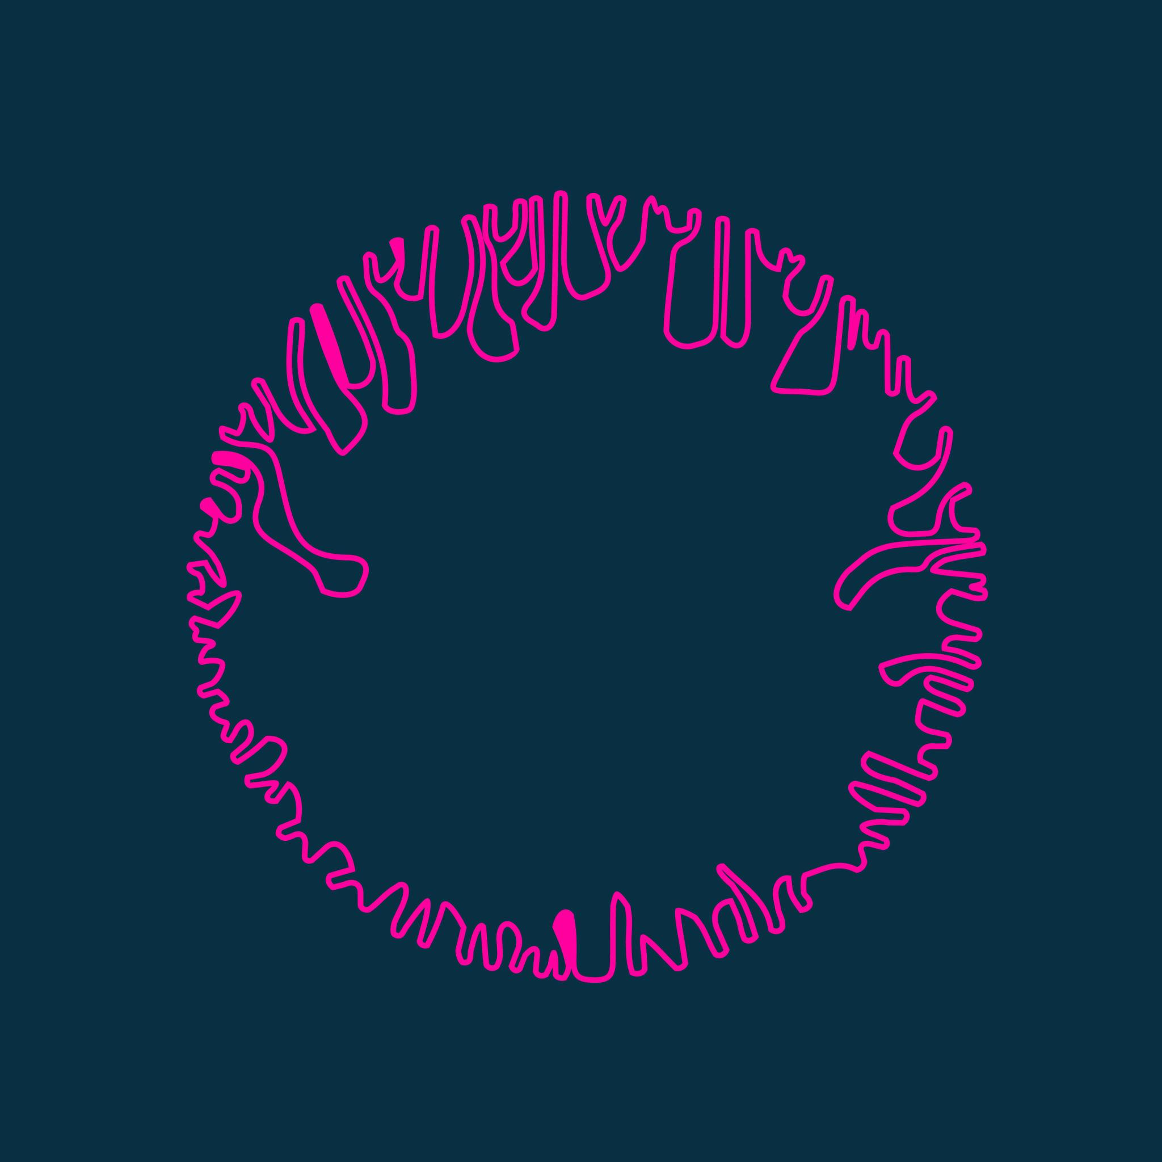
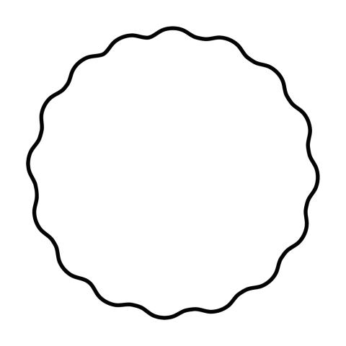
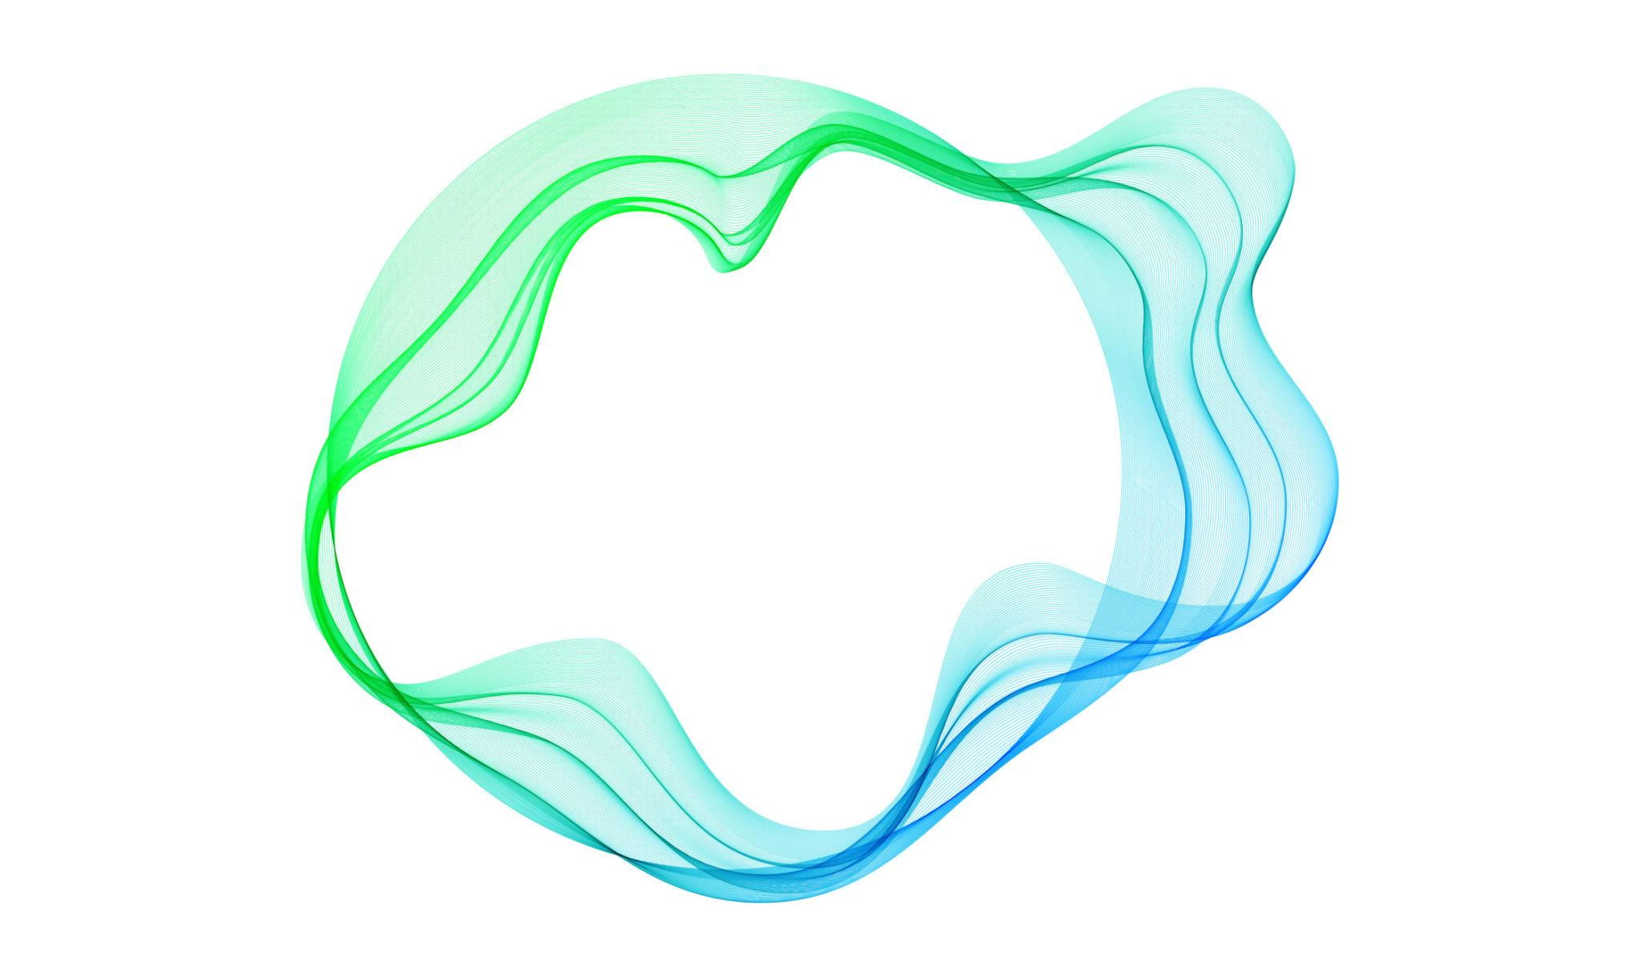
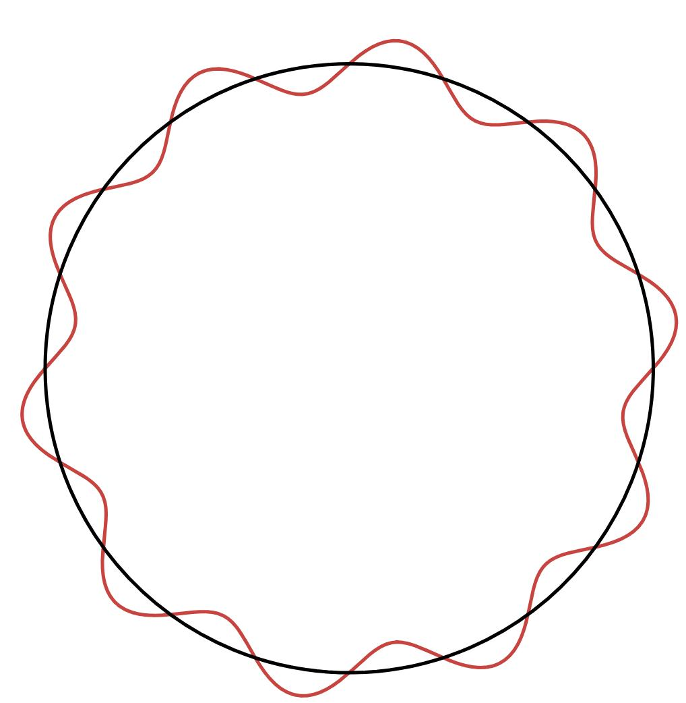
The wavy portion can have varying:
- Amplitude.
- Spacing.
- Curvature.
- Number of undulations.

5. Circle–Freeform Organic Closed Shapes
# Source: AI Source: Provided by: [Data Path: Persons Table -> ID Column: 1, Name_En Column: Motasem Essam] -> From: [ChatGPT] on [7/25/2026]
A circular component is connected to a freely designed organic curve.
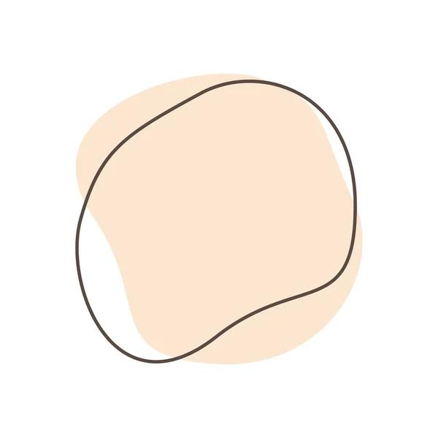
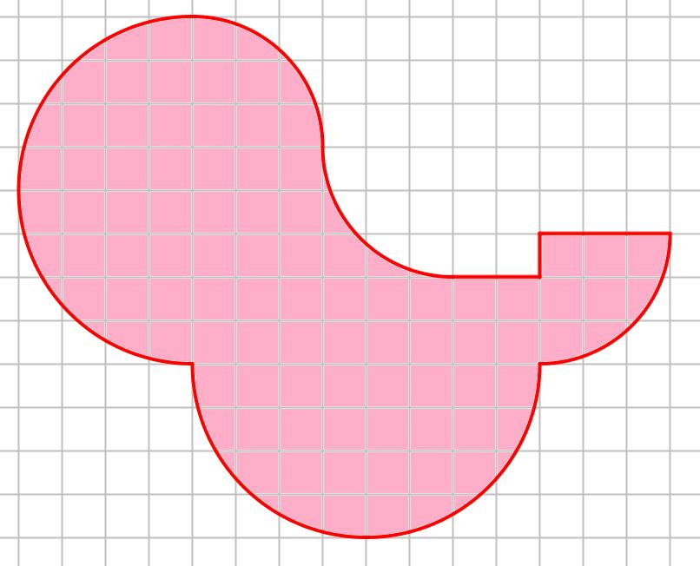
This combines:
$$\boxed{\text{Circular Geometry}+\text{Freeform Organic Geometry}}$$

6. Circle–Asymmetric Organic Closed Shapes
# Source: AI Source: Provided by: [Data Path: Persons Table -> ID Column: 1, Name_En Column: Motasem Essam] -> From: [ChatGPT] on [7/25/2026]
The circular portion is combined with an organic curve that creates an overall asymmetric form.
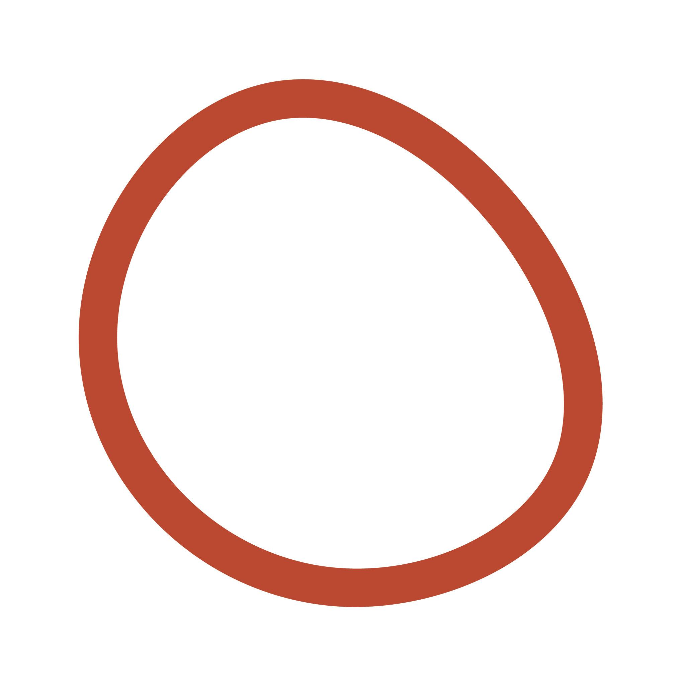

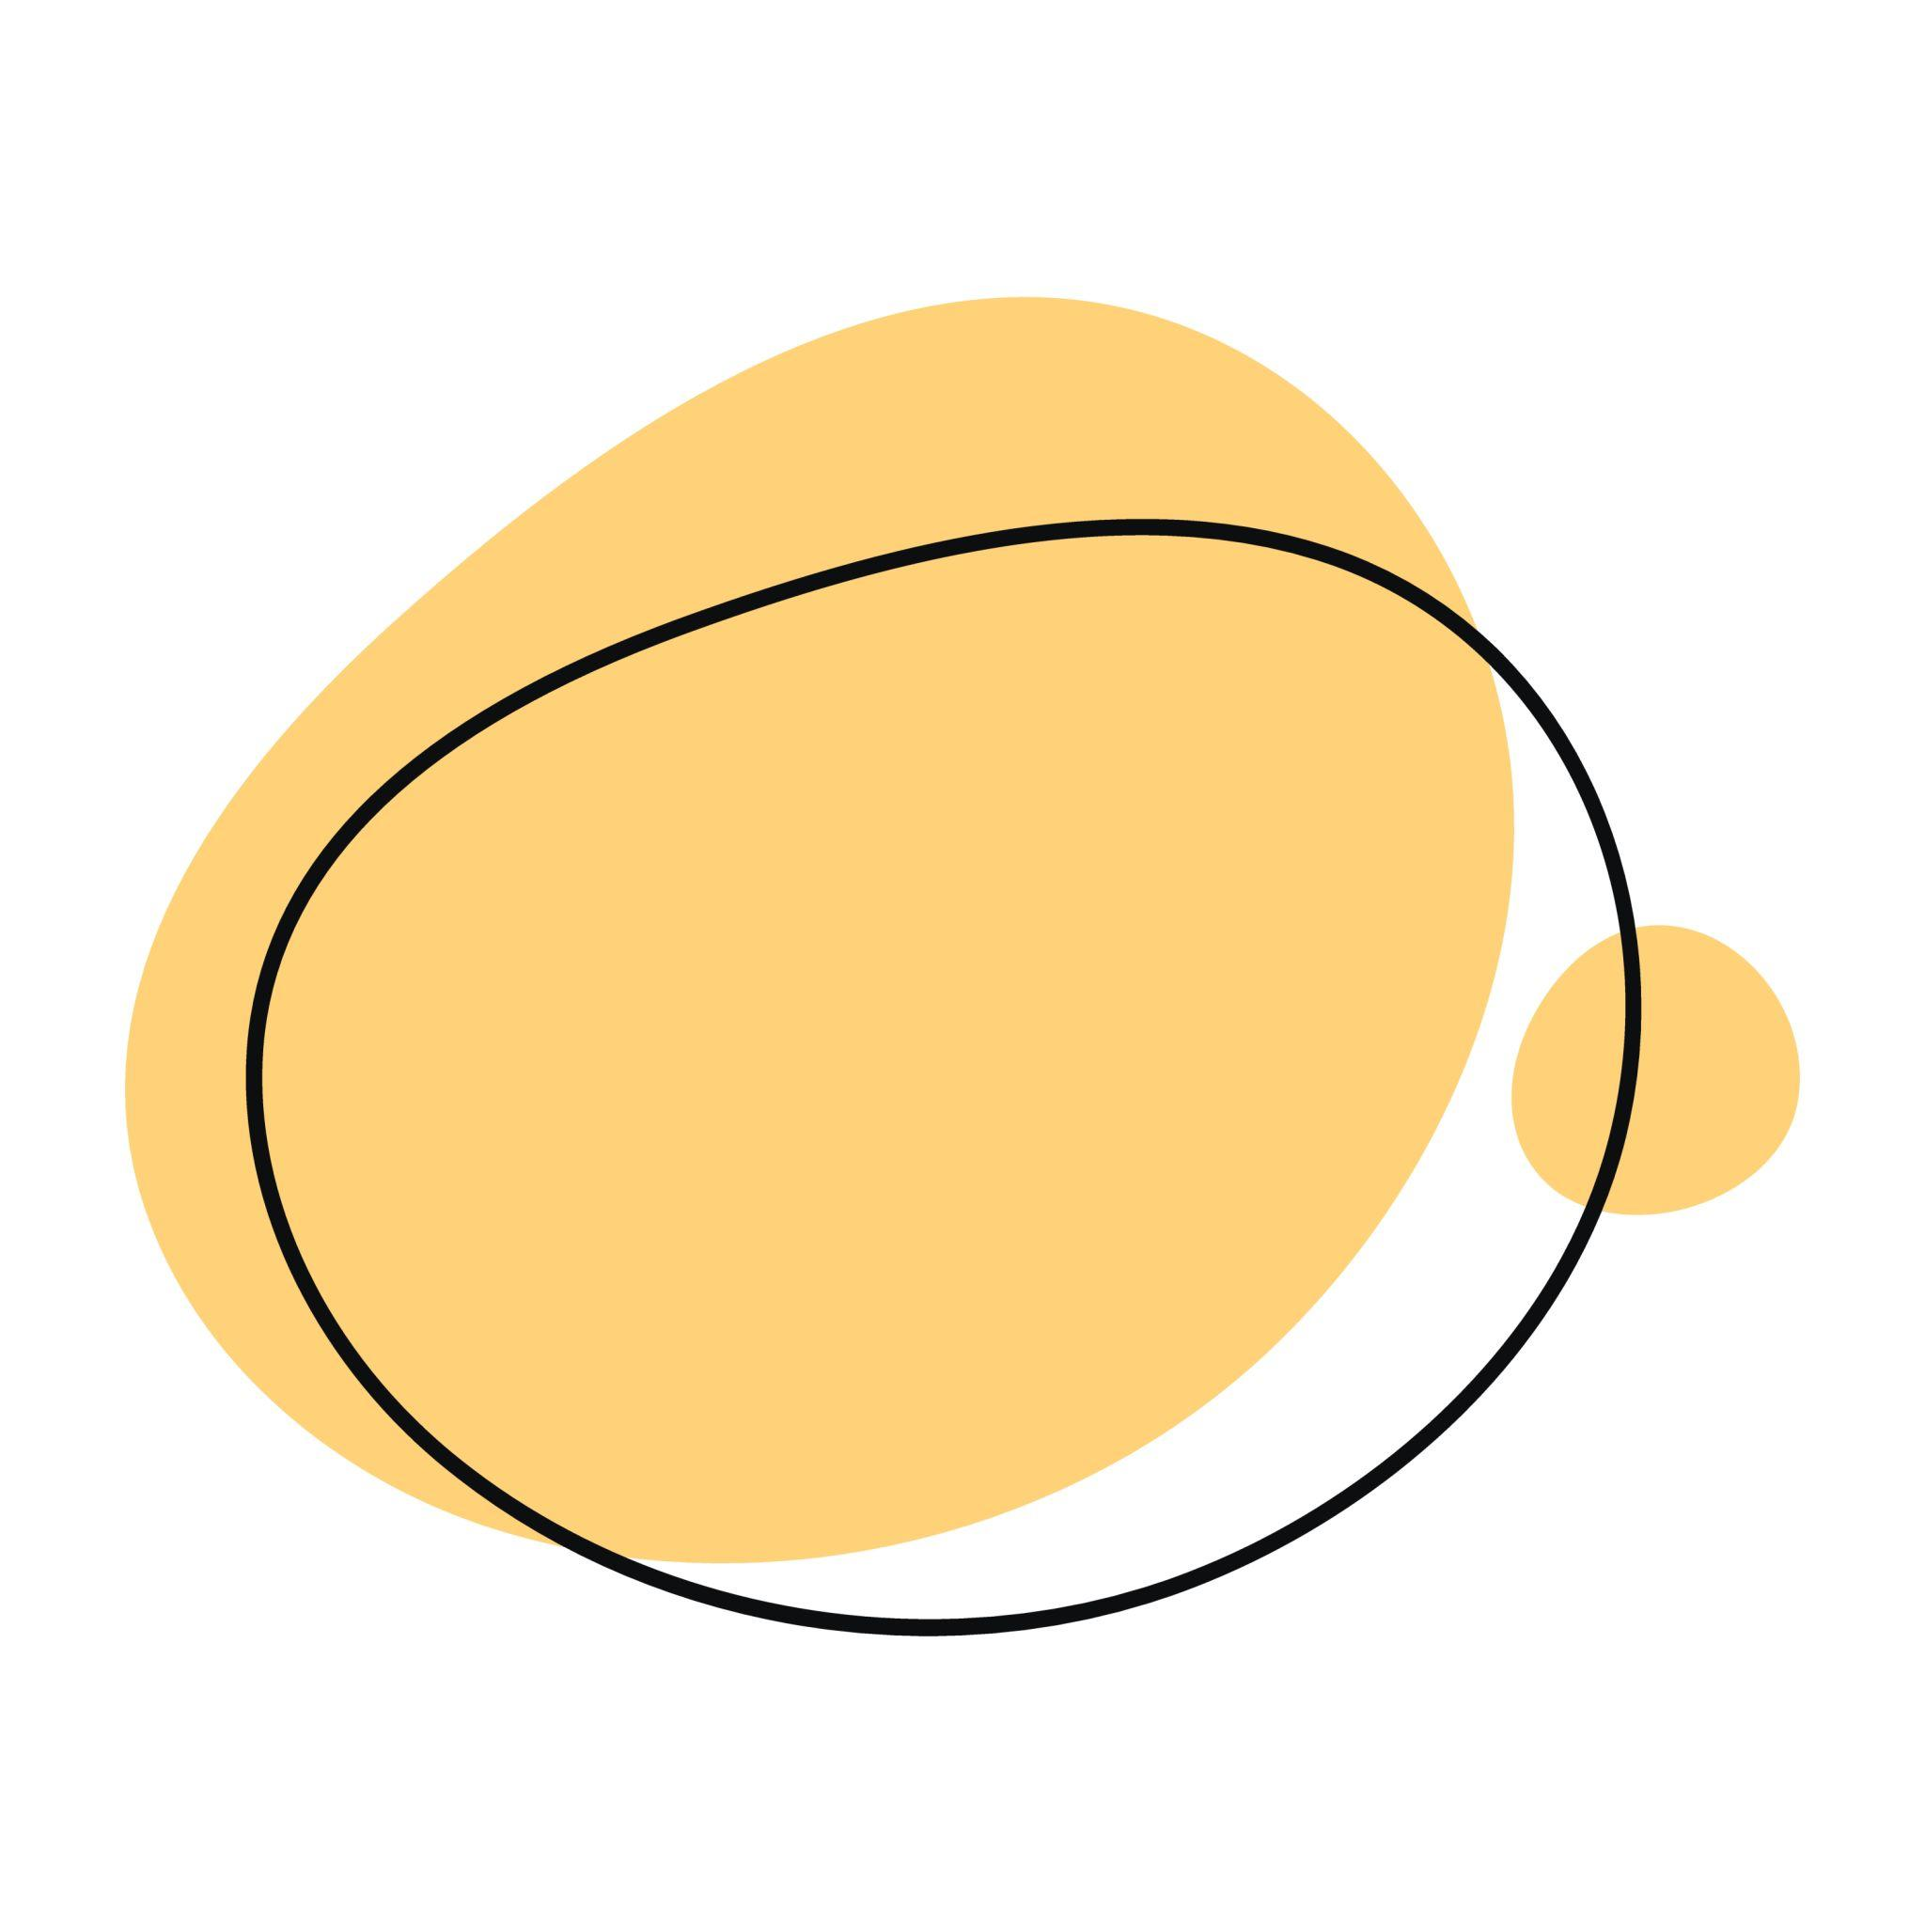
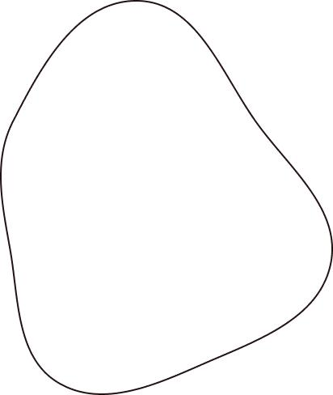
The overall boundary has no regular reflection symmetry.

7. Circle–Bulging Organic Closed Shapes
# Source: AI Source: Provided by: [Data Path: Persons Table -> ID Column: 1, Name_En Column: Motasem Essam] -> From: [ChatGPT] on [7/25/2026]
A circular portion is combined with outward organic bulges.
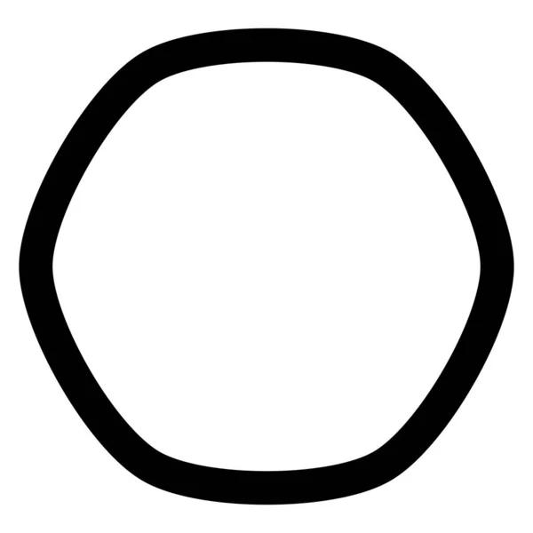

The bulges can have different sizes and curvature.

8. Circle–Indented Organic Closed Shapes
# Source: AI Source: Provided by: [Data Path: Persons Table -> ID Column: 1, Name_En Column: Motasem Essam] -> From: [ChatGPT] on [7/25/2026]
A circular portion is combined with inward organic indentations.
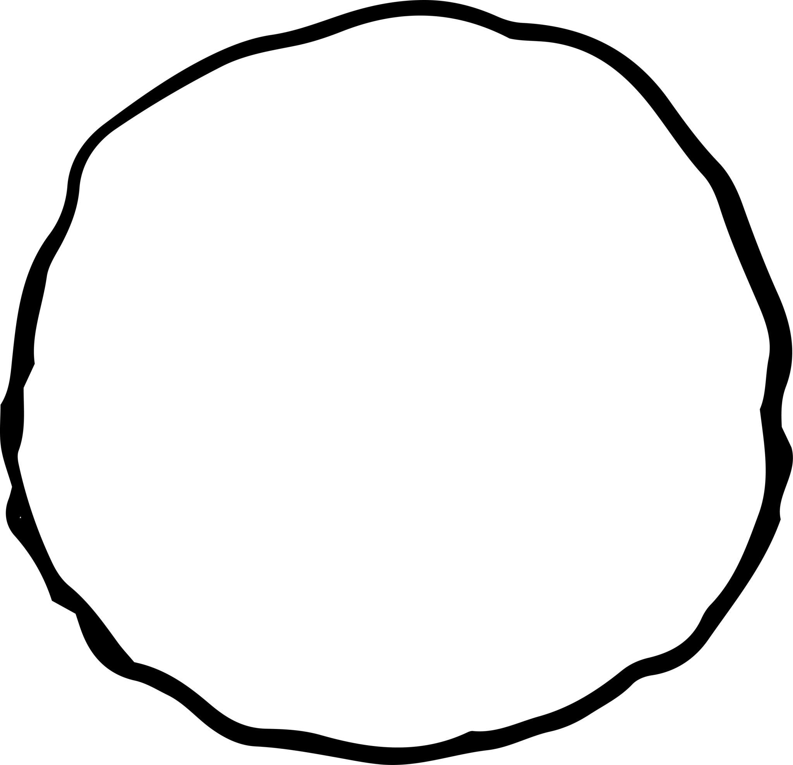
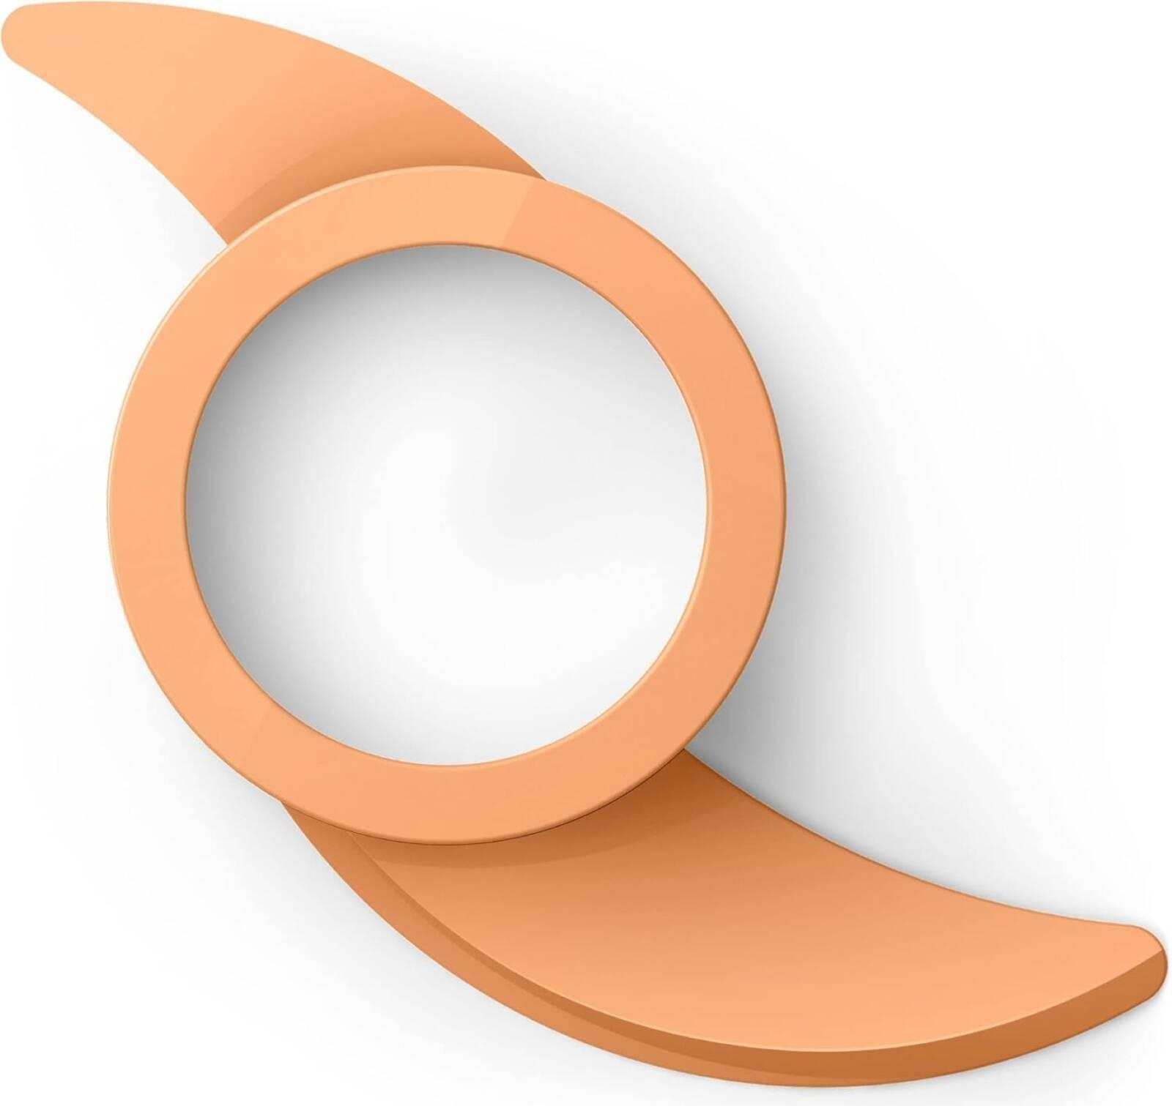
If an indentation extends sufficiently inward, the resulting closed shape can become concave.

9. Circular–Natural Organic Closed Shapes
# Source: AI Source: Provided by: [Data Path: Persons Table -> ID Column: 1, Name_En Column: Motasem Essam] -> From: [ChatGPT] on [7/25/2026]
A circular component is combined with a curve that resembles a naturally occurring form.
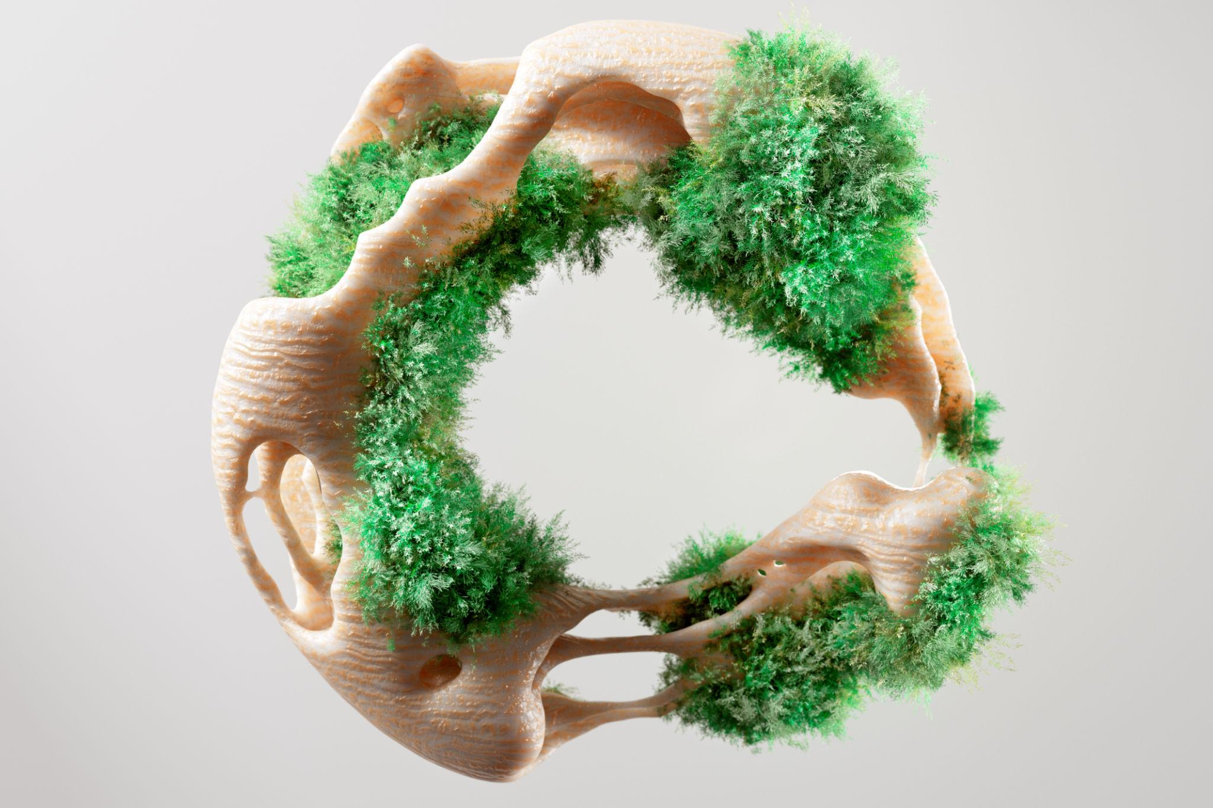
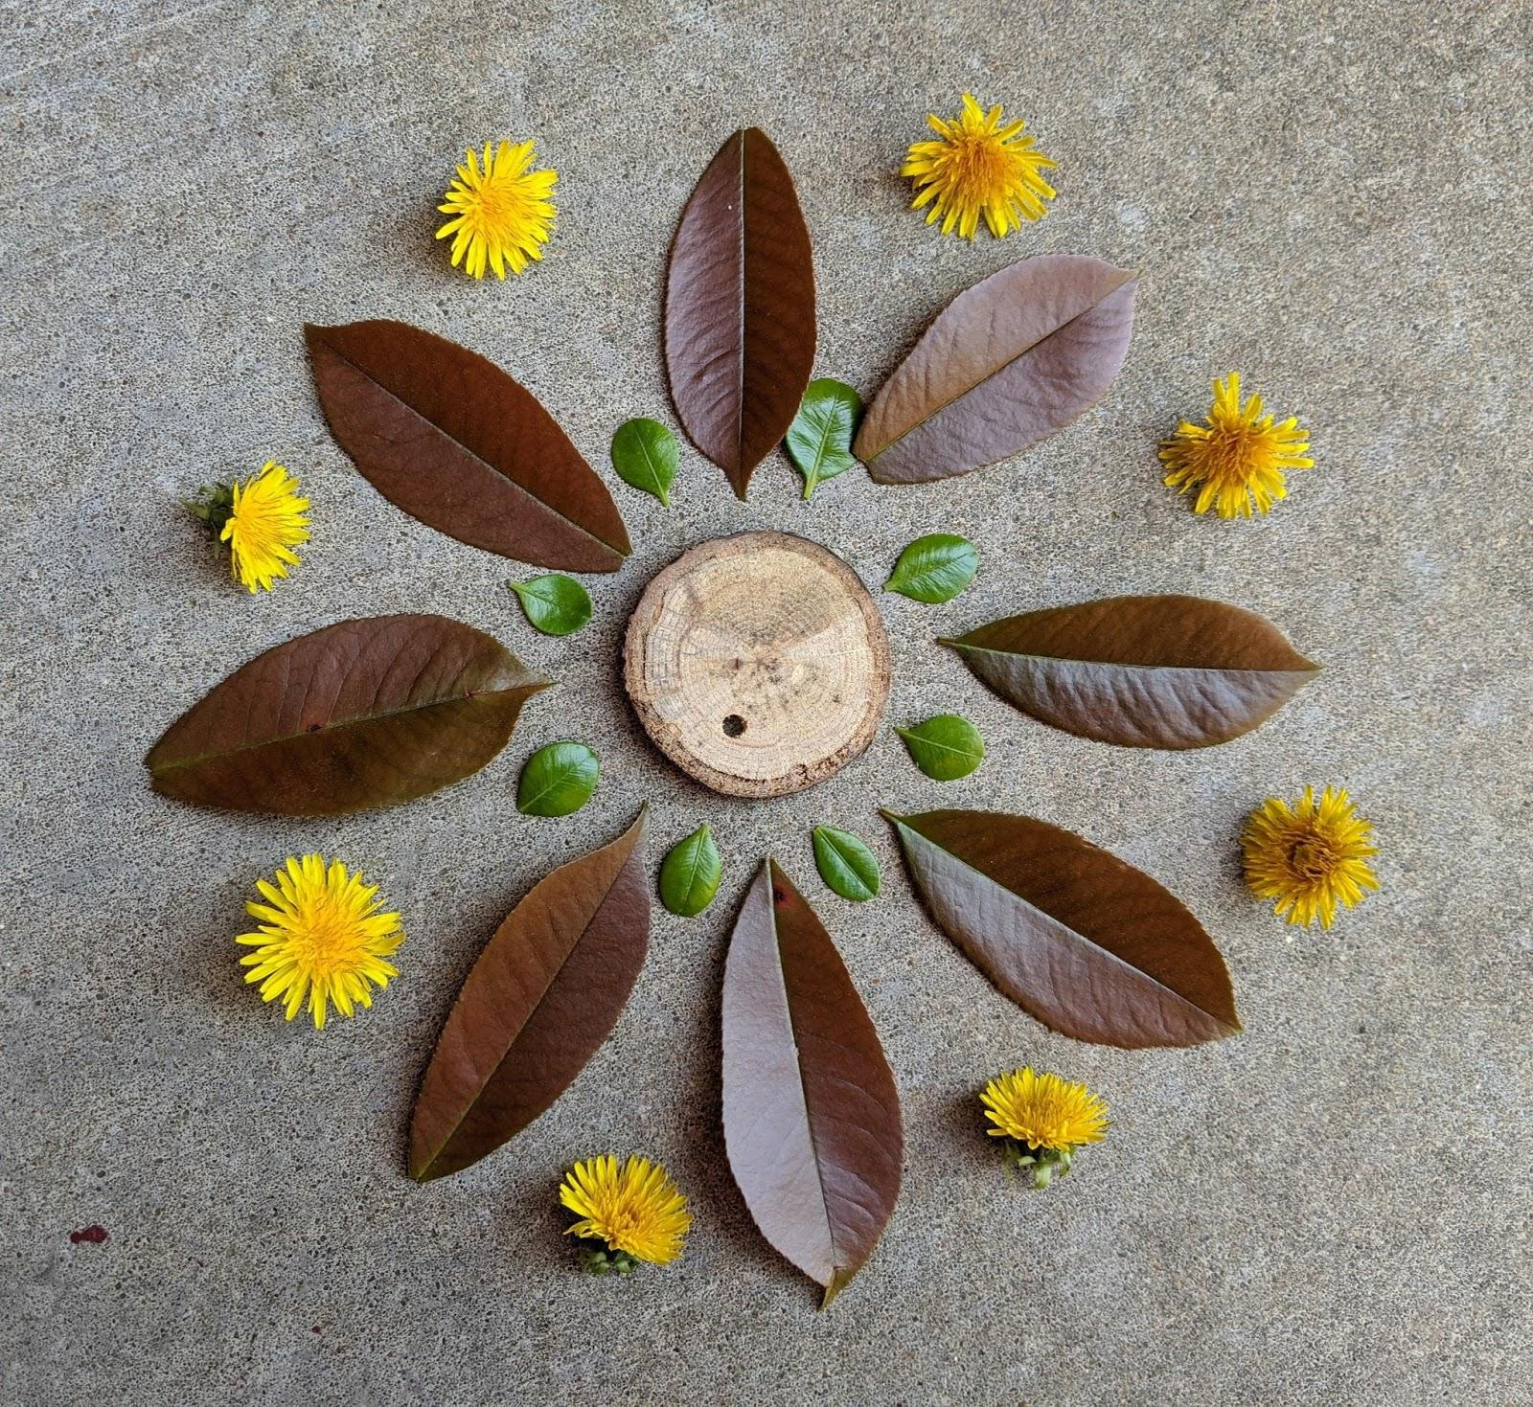
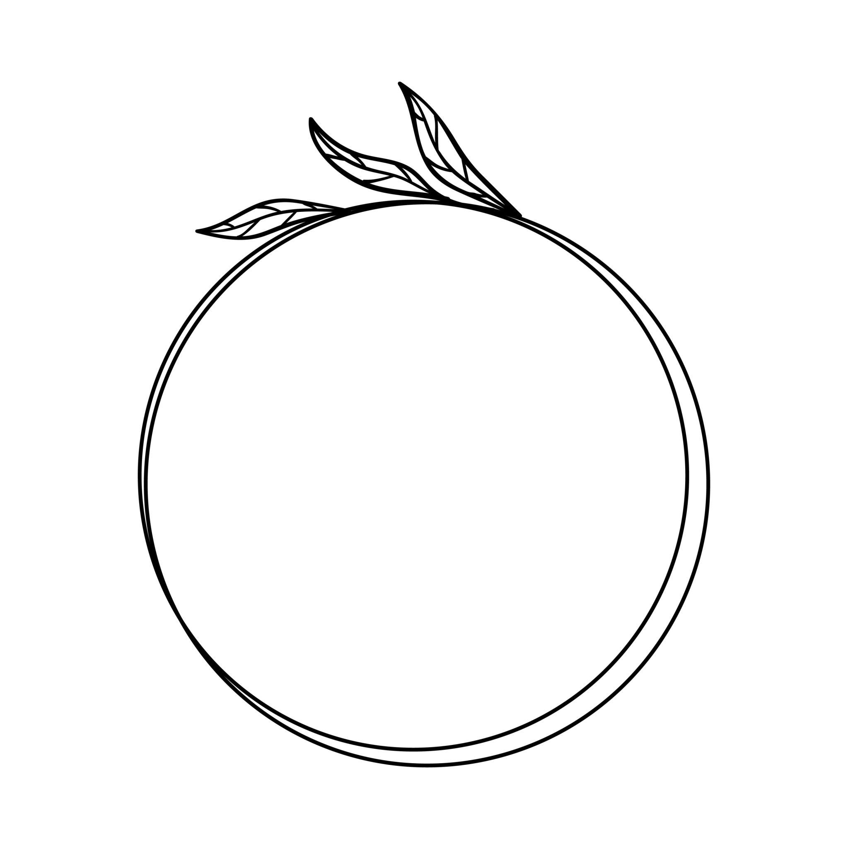
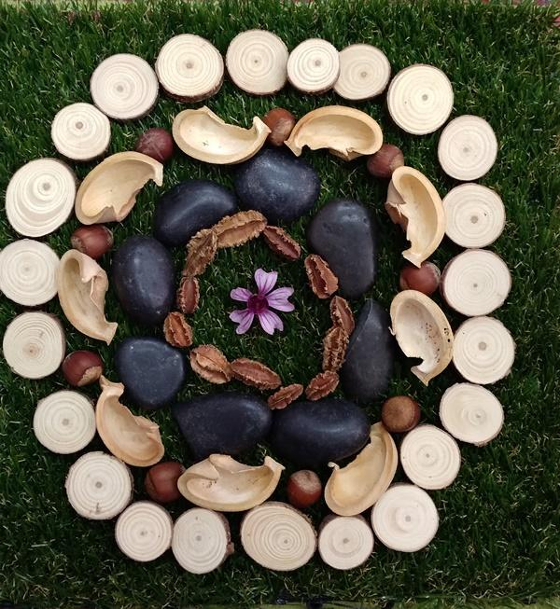
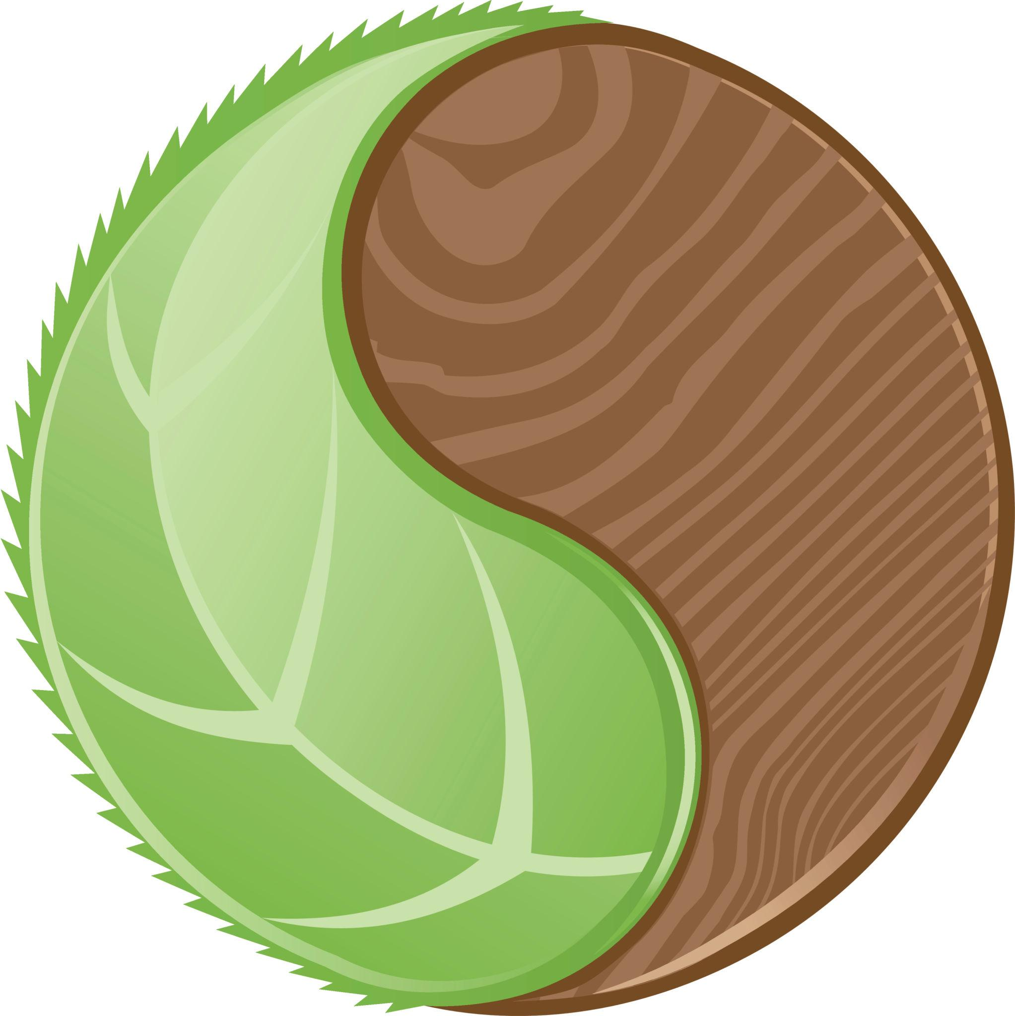
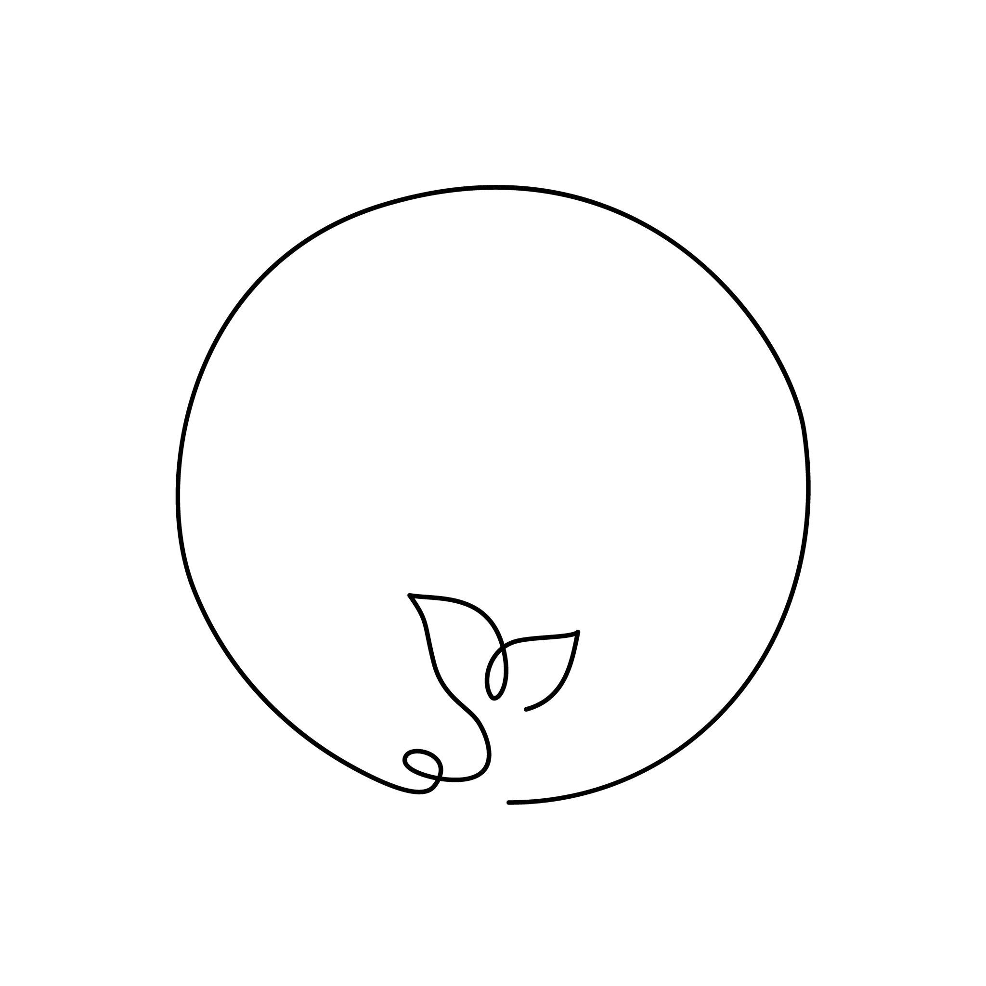
The organic portion may resemble:
- A leaf.
- A seed.
- A petal.
- A stone.
- A biological form.

10. Irregular Circular–Organic Closed Shapes
# Source: AI Source: Provided by: [Data Path: Persons Table -> ID Column: 1, Name_En Column: Motasem Essam] -> From: [ChatGPT] on [7/25/2026]
These combine a circular portion with an irregular organic boundary.
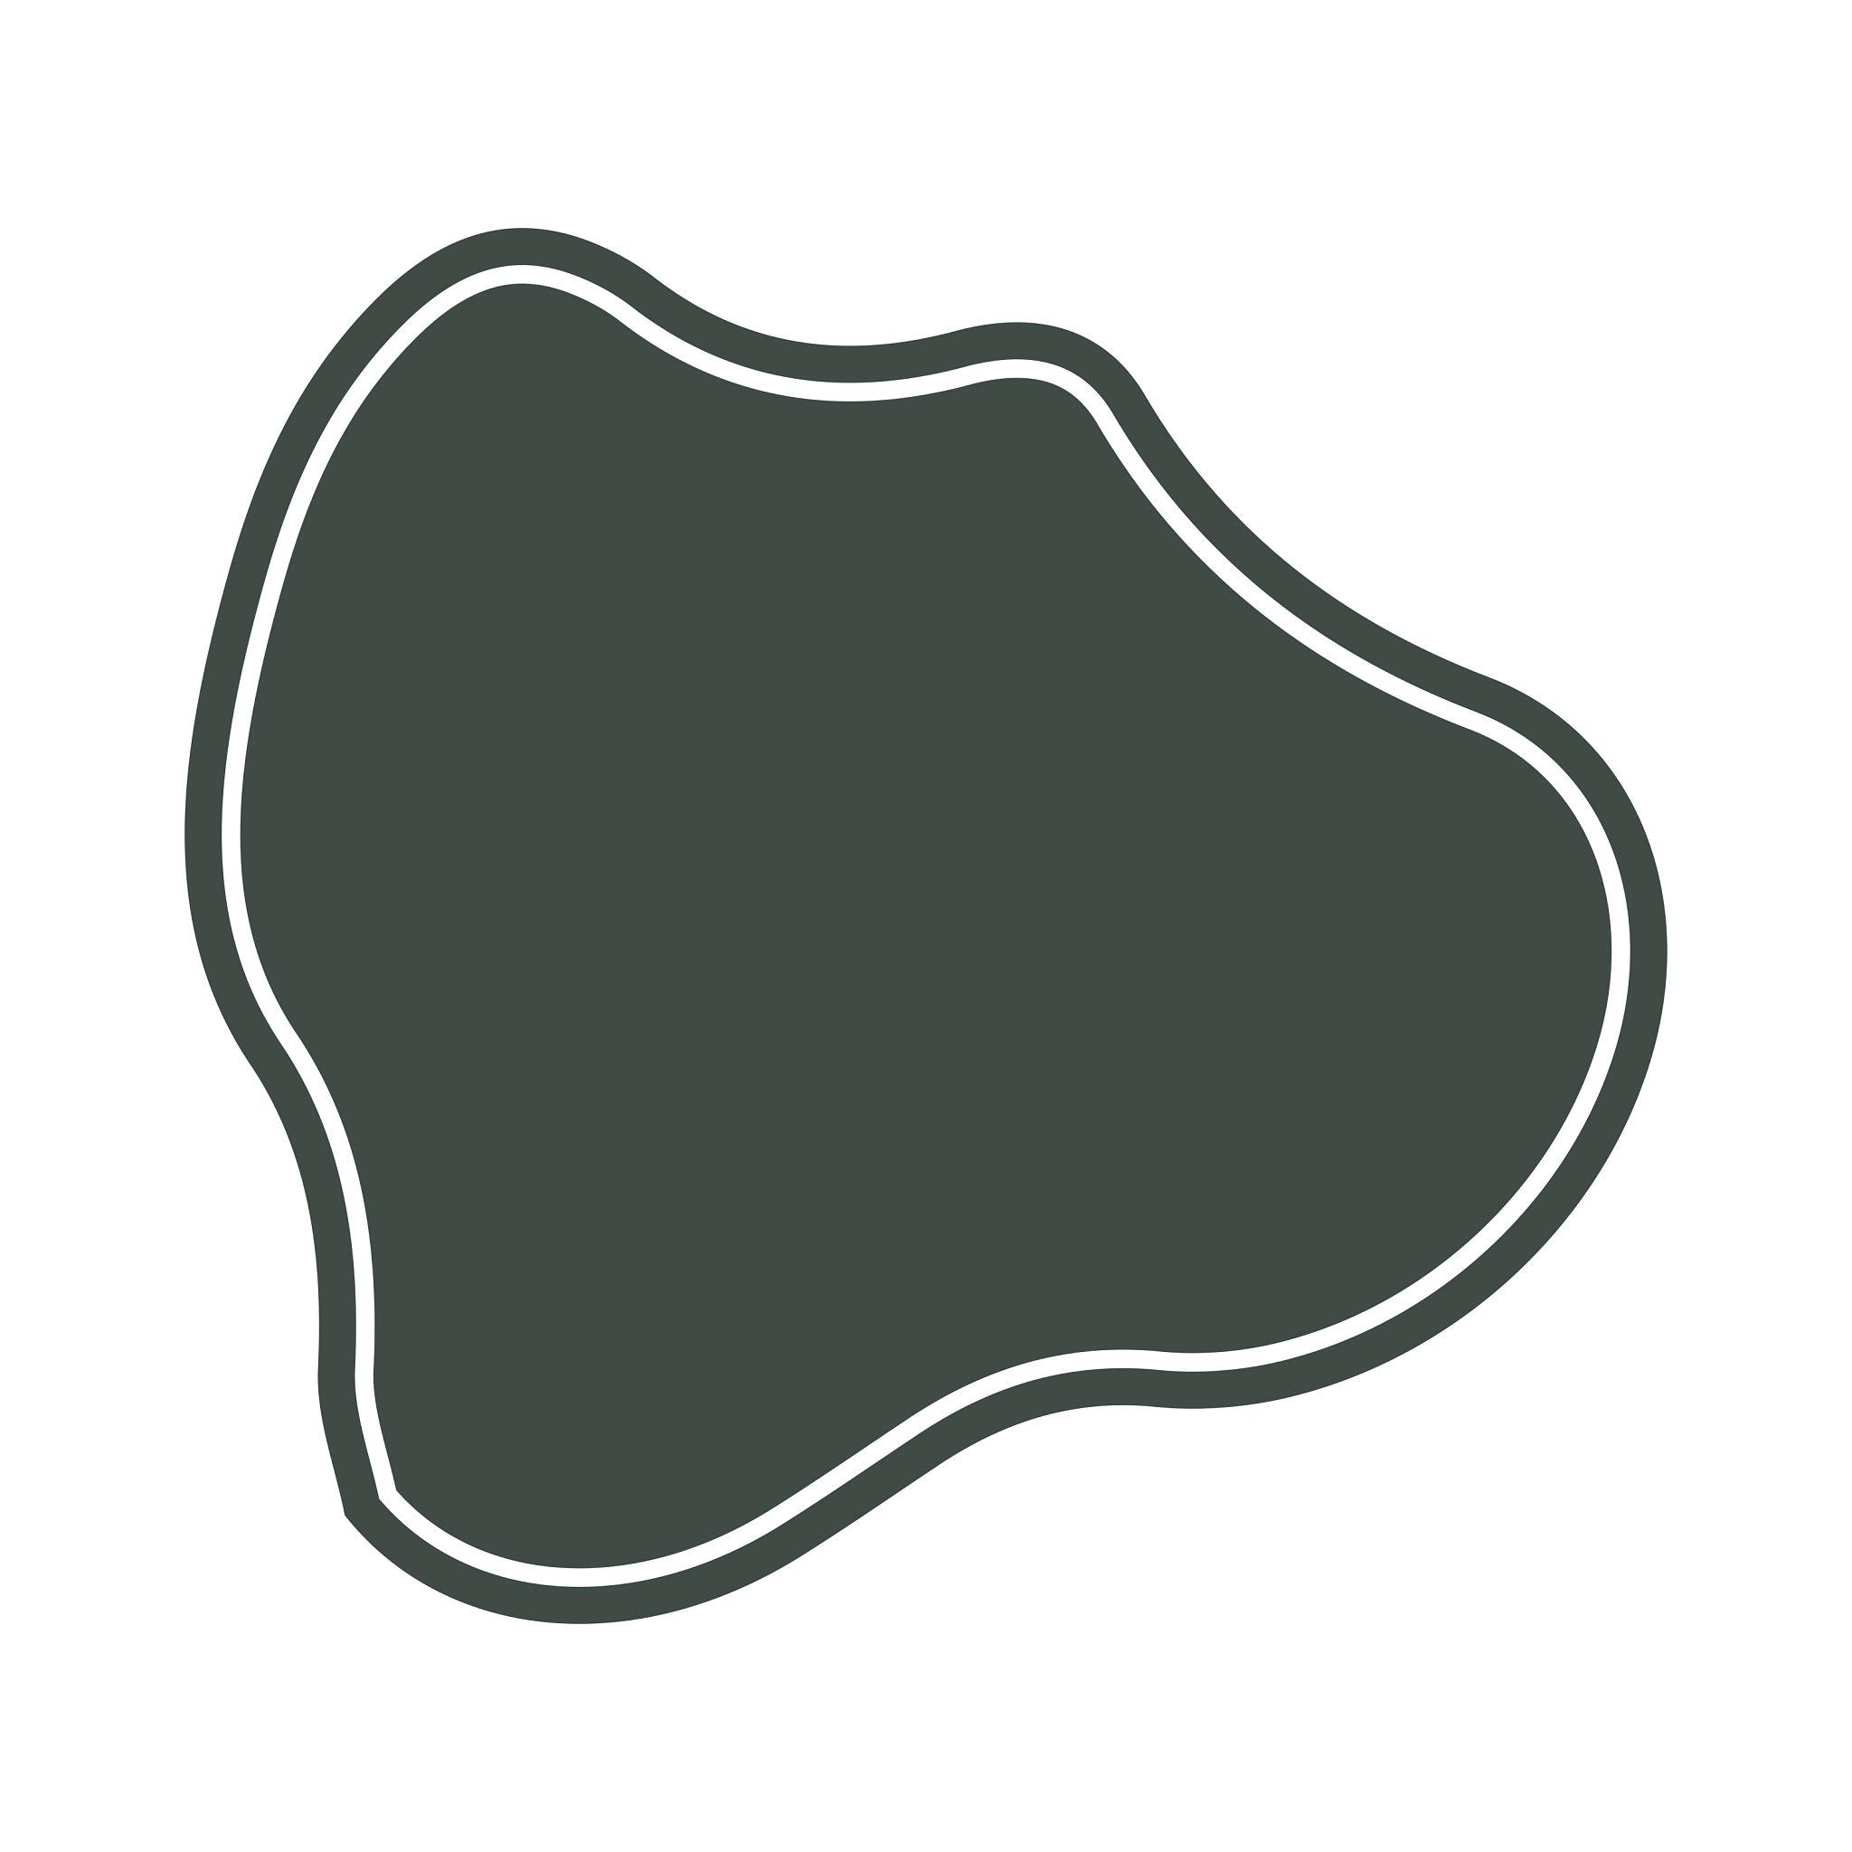
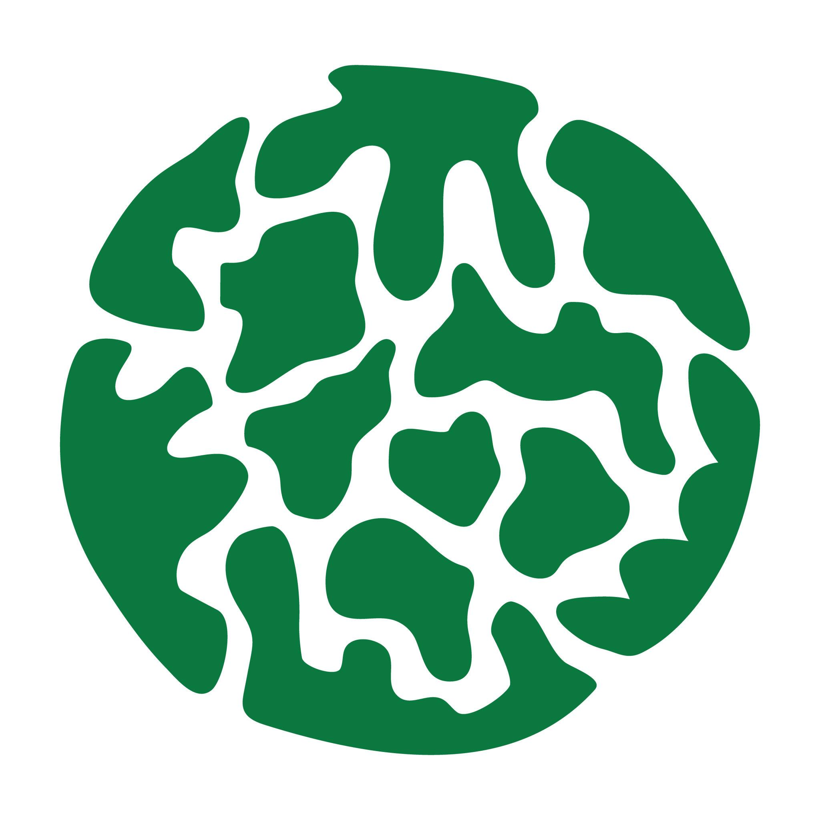
This is the most general subtype and can contain multiple circular and organic components.

Circular–Organic vs. Polygon–Organic
# Source: AI Source: Provided by: [Data Path: Persons Table -> ID Column: 1, Name_En Column: Motasem Essam] -> From: [ChatGPT] on [7/25/2026]
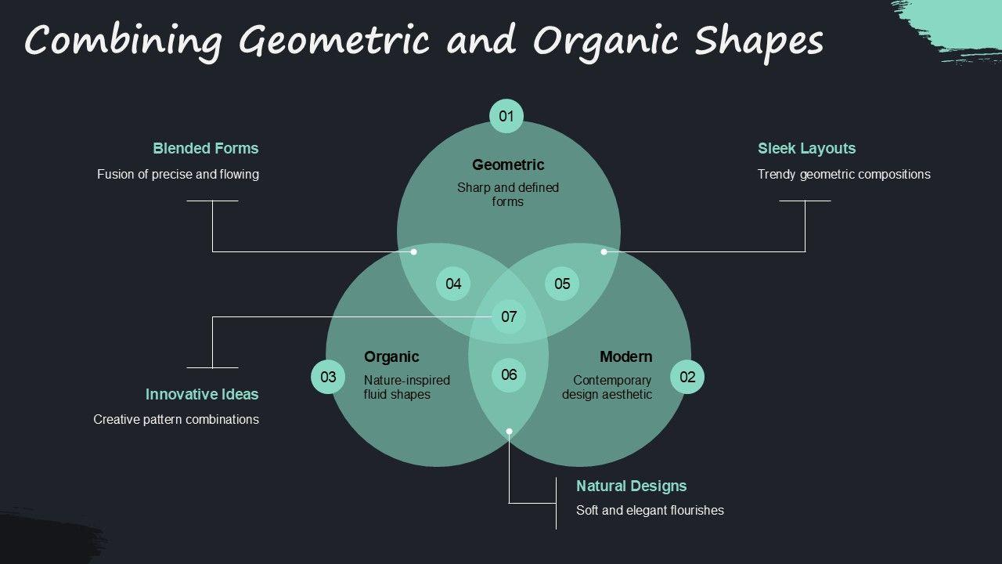
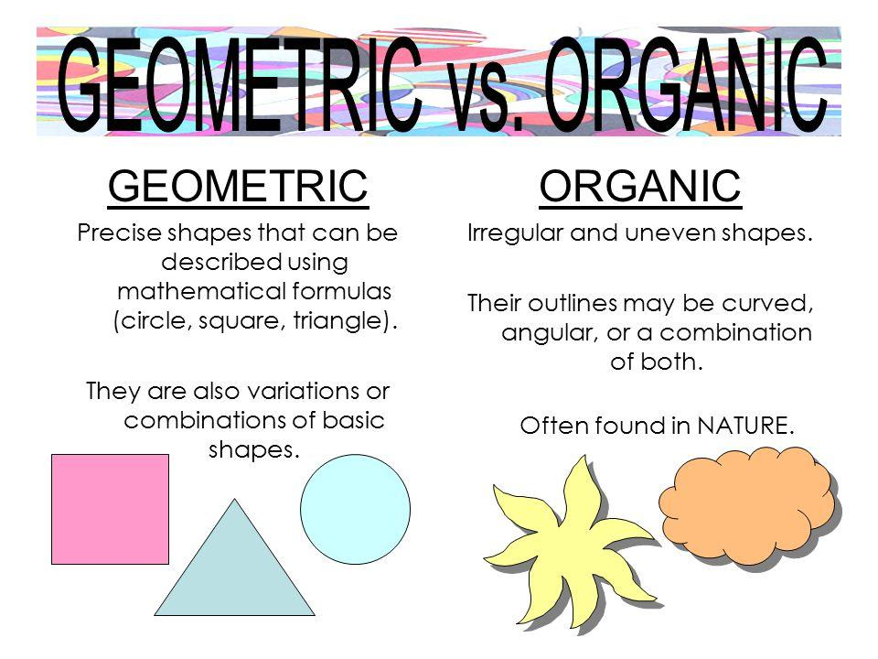
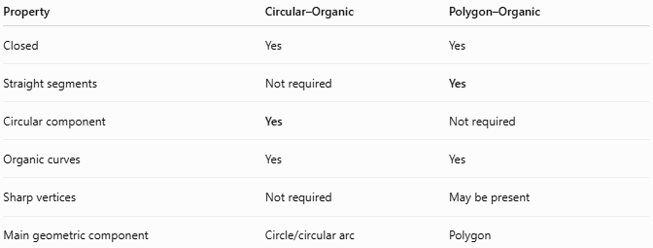
Property | Circular–Organic | Polygon–Organic
Closed | Yes | Yes
Straight segments | Not required | Yes
Circular component | Yes | Not required
Organic curves | Yes | Yes
Sharp vertices | Not required | May be present
Main geometric component | Circle/circular arc | Polygon
The main distinction is:
$$\boxed{\text{Circular–Organic}→\text{Circular Geometry + Organic Curves}}$$
while:
$$\boxed{\text{Polygon–Organic}→\text{Polygonal Geometry + Organic Curves}}$$

Circular–Organic vs. Circular–Freeform
# Source: AI Source: Provided by: [Data Path: Persons Table -> ID Column: 1, Name_En Column: Motasem Essam] -> From: [ChatGPT] on [7/25/2026]
These categories can also overlap.
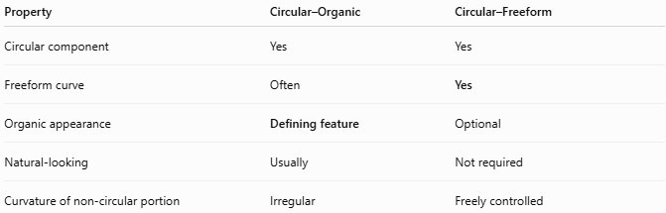
Property | Circular–Organic | Circular–Freeform
Circular component | Yes | Yes
Freeform curve | Often | Yes
Organic appearance | Defining feature | Optional
Natural-looking | Usually | Not required
Curvature of non-circular portion | Irregular | Freely controlled
For example, a circular shape combined with a deliberately designed abstract curve is Circular–Freeform, while a circular shape combined with a leaf-like natural curve can be Circular–Organic.

Circular–Organic vs. Pure Circular Shapes
# Source: AI Source: Provided by: [Data Path: Persons Table -> ID Column: 1, Name_En Column: Motasem Essam] -> From: [ChatGPT] on [7/25/2026]
A pure circular shape has a boundary consisting entirely of circular geometry.
$$\boxed{\text{Pure Circular Shape}=\text{Circular Boundary Only}}$$
A circular–organic mixed shape contains another type of curved geometry:
$$\boxed{\text{Circular–Organic}=\text{Circular Boundary}+\text{Organic Boundary}}$$

Area
# Source: AI Source: Provided by: [Data Path: Persons Table -> ID Column: 1, Name_En Column: Motasem Essam] -> From: [ChatGPT] on [7/25/2026]
A Circular–Organic Closed Shape is a composite region.
Its area may be calculated by decomposition:
$$\boxed{A_{\text{total}}=A_{\text{circular}}±A_{\text{organic}}}$$
For example, if a circular region is combined with an additional organic region:
$$A_{\text{total}}=πr^{2}+A_{\text{organic}}$$
The organic portion generally requires numerical measurement or integration unless it has a known mathematical description.

Perimeter
# Source: AI Source: Provided by: [Data Path: Persons Table -> ID Column: 1, Name_En Column: Motasem Essam] -> From: [ChatGPT] on [7/25/2026]
The perimeter contains circular and organic curved portions:
$$\boxed{P=L_{\text{circular}}+L_{\text{organic}}}$$
For a circular arc:
$$L_{\text{arc}}=rθ$$
where (\theta) is measured in radians.
The organic portion generally requires an arc-length calculation or numerical measurement.

Key Points
# Source: AI Source: Provided by: [Data Path: Persons Table -> ID Column: 1, Name_En Column: Motasem Essam] -> From: [ChatGPT] on [7/25/2026]
A Circular–Organic Closed Shape is:
$$\boxed{\text{Closed}+\text{Circular Component}+\text{Organic Curved Component}}$$
It:
- Has a completely closed boundary.
- Contains circular geometry.
- Contains organic-looking curved geometry.
- Has no requirement for straight polygonal segments.
- May be symmetric or asymmetric.
- May be regular-looking or irregular.
- May contain wavy, lobed, bulging, or indented portions.

Conclusion
# Source: AI Source: Provided by: [Data Path: Persons Table -> ID Column: 1, Name_En Column: Motasem Essam] -> From: [ChatGPT] on [7/25/2026]
Circular–Organic Closed Shapes are mixed closed shapes that combine circular geometry with irregular, smooth, organic-looking curves. They include circle–leaf-like, circle–lobed, circle–wavy, circle–freeform, circle–asymmetric, circle–bulging, circle–indented, and natural organic forms. The key distinction is that the shape contains a recognizable circular component while another part of its boundary has an organic, non-standard curved form.

